**Oracle Administrator Workshop I (LAB)**

**NAME: CHUOB Bunthoeurn**

**DOB: 04 April 1995**

# Lab 1: Install Oracle

Add domain and change hostname.



Now we install using Automatic setup.



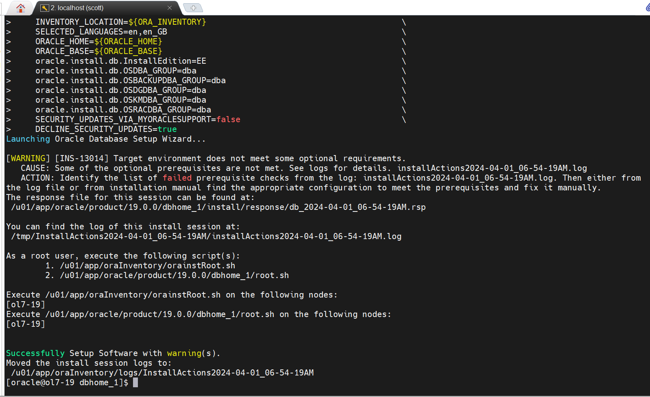

Figure . Setting UP Software

Change oracle user’s password.



Set secure Linux to permissive.



SELINUX=permissive

Addional configuration



Now let’s install Oracle Database Using silent mode:

* Update /home/oracle/scripts/.bash_profile as the following

[root@ol7-19 admin]# cat /home/oracle/.bash_profile

# .bash_profile

# Get the aliases and functions

if [ -f ~/.bashrc ]; then

    . ~/.bashrc

fi

# User specific environment and startup programs

PATH=$PATH:$HOME/.local/bin:$HOME/bin:/usr/bin

export PATH

#Oracle Settings

export TMP=/tmp

export TMPDIR=$TMP

export ORACLE_HOSTNAME=ol7-19.localhost

export ORACLE_UNQNAME=cdb1

export ORACLE_BASE=/u01/app/oracle

export ORACLE_HOME=$ORACLE_BASE/product/19.0.0/dbhome_1

export ORA_INVENTORY=/u01/app/oraInventory

export ORACLE_SID=cdb1

export PDB_NAME=pdb1

export DATA_DIR=/u02/oradata

export PATH=/usr/sbin:/usr/local/bin:$PATH

export PATH=$ORACLE_HOME/bin:$PATH

export LD_LIBRARY_PATH=$ORACLE_HOME/lib:/lib:/usr/lib

export CLASSPATH=$ORACLE_HOME/jlib:$ORACLE_HOME/rdbms/jlib

Upload LINUX.X64_193000_db_home.zip to Linux server path: /home/scott then unzip the software

cd $ORACLE_HOME

. .bash_profile

unzip -oq /home/scott/LINUX.X64_193000_db_home.zip

let’s install Oracle Database



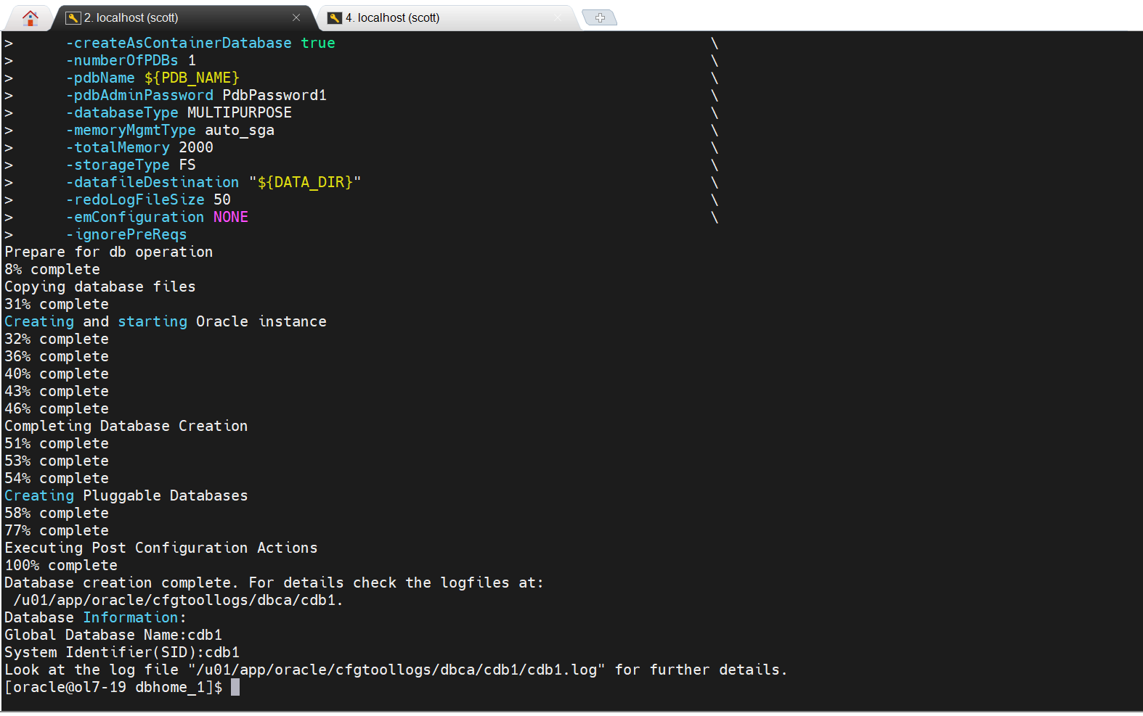

Figure . Install Oracle

Create a container Database.



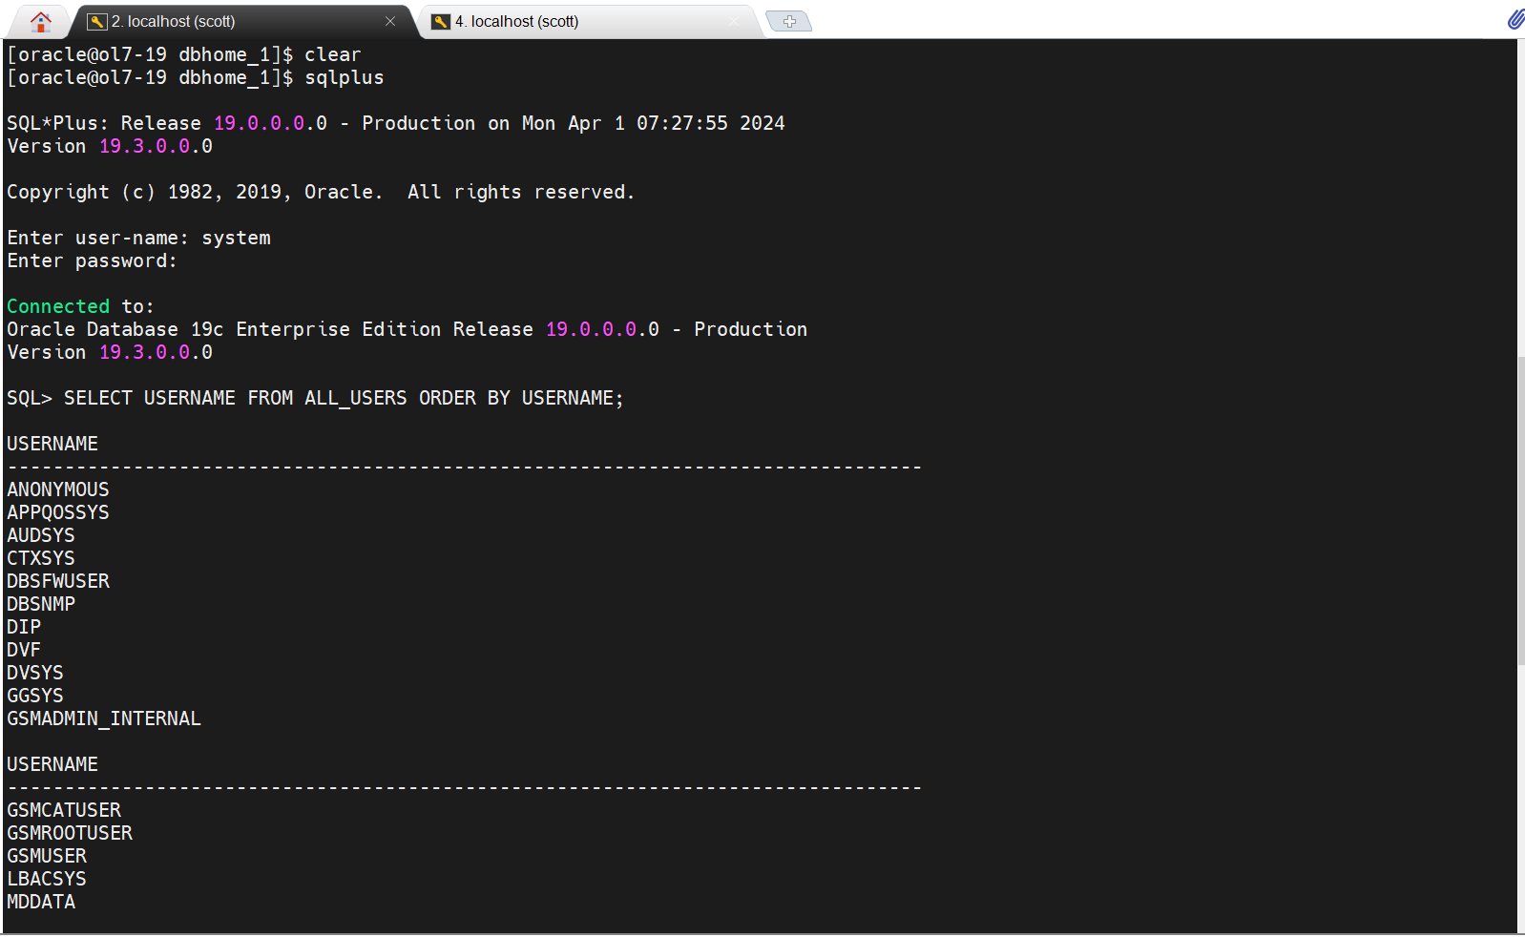

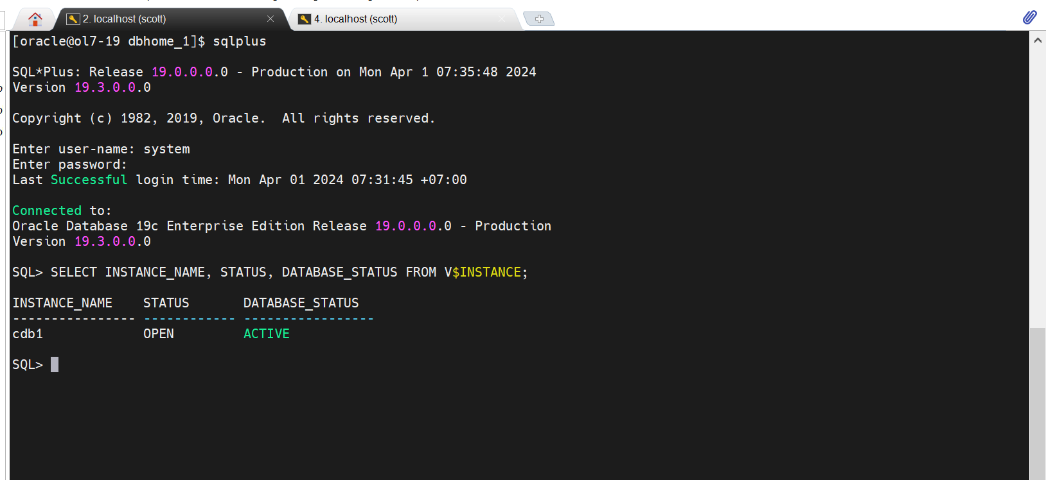

Figure . Pluggable Database

# Lab 2. Spool Query Results

Snapshot to prevent issue before process the Lab 2.

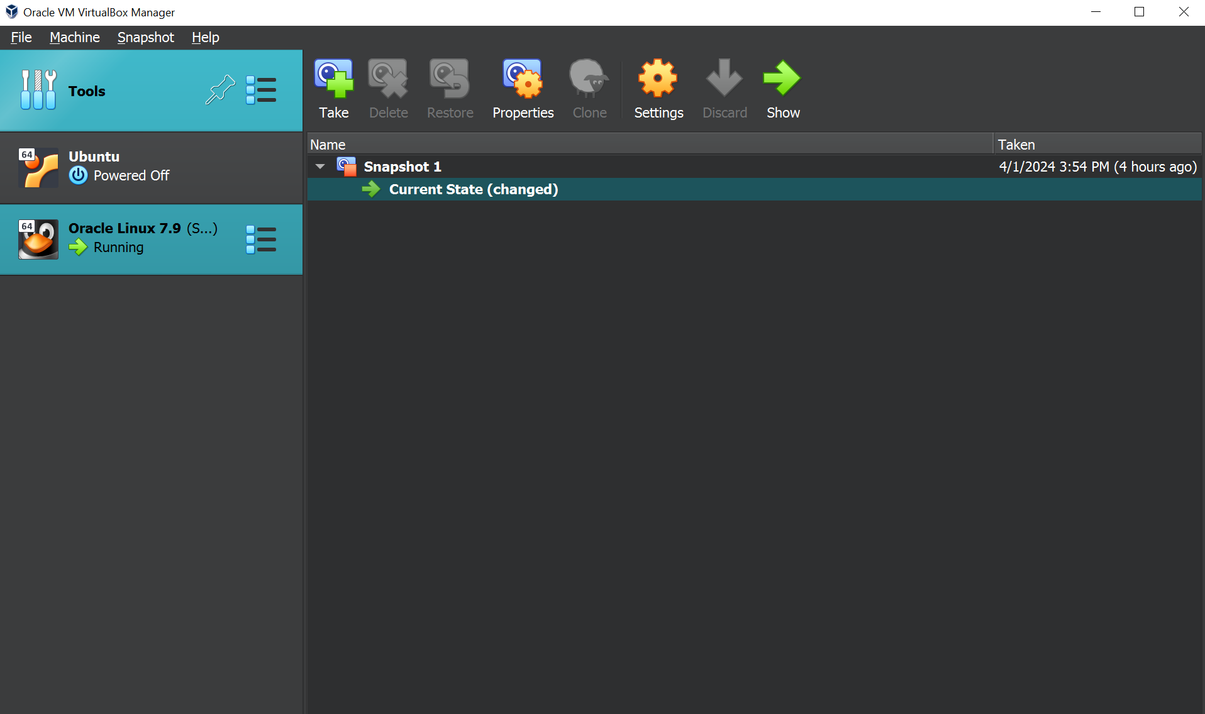

Figure . VM Snapshot

Create non-container database.





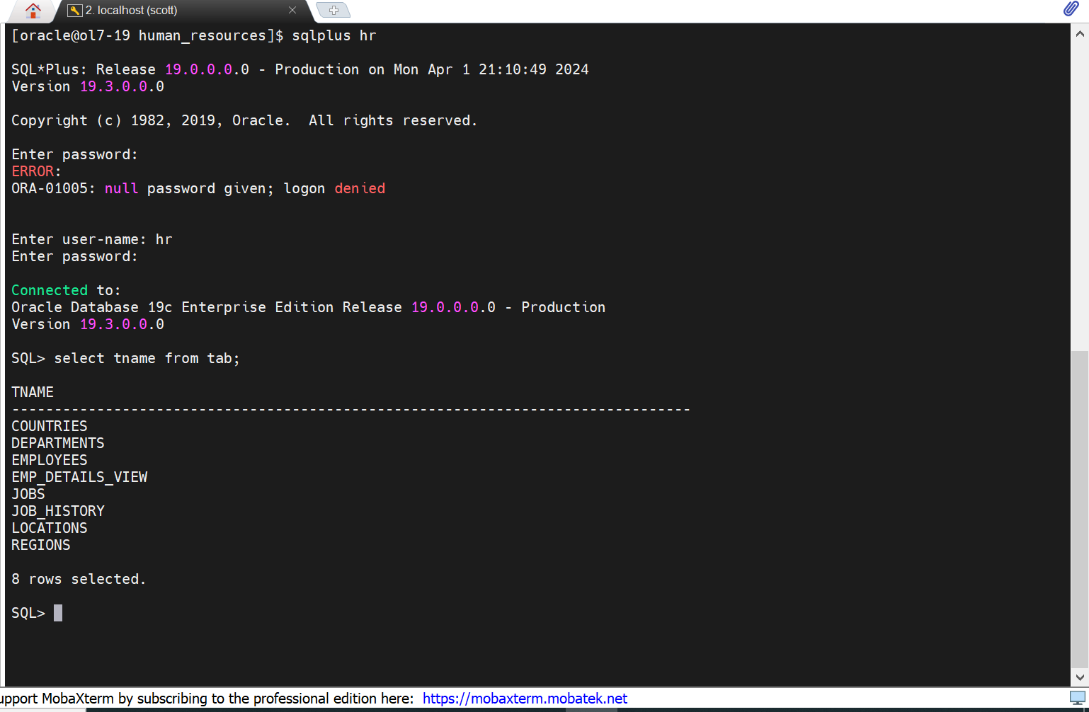

Figure . Demo Table

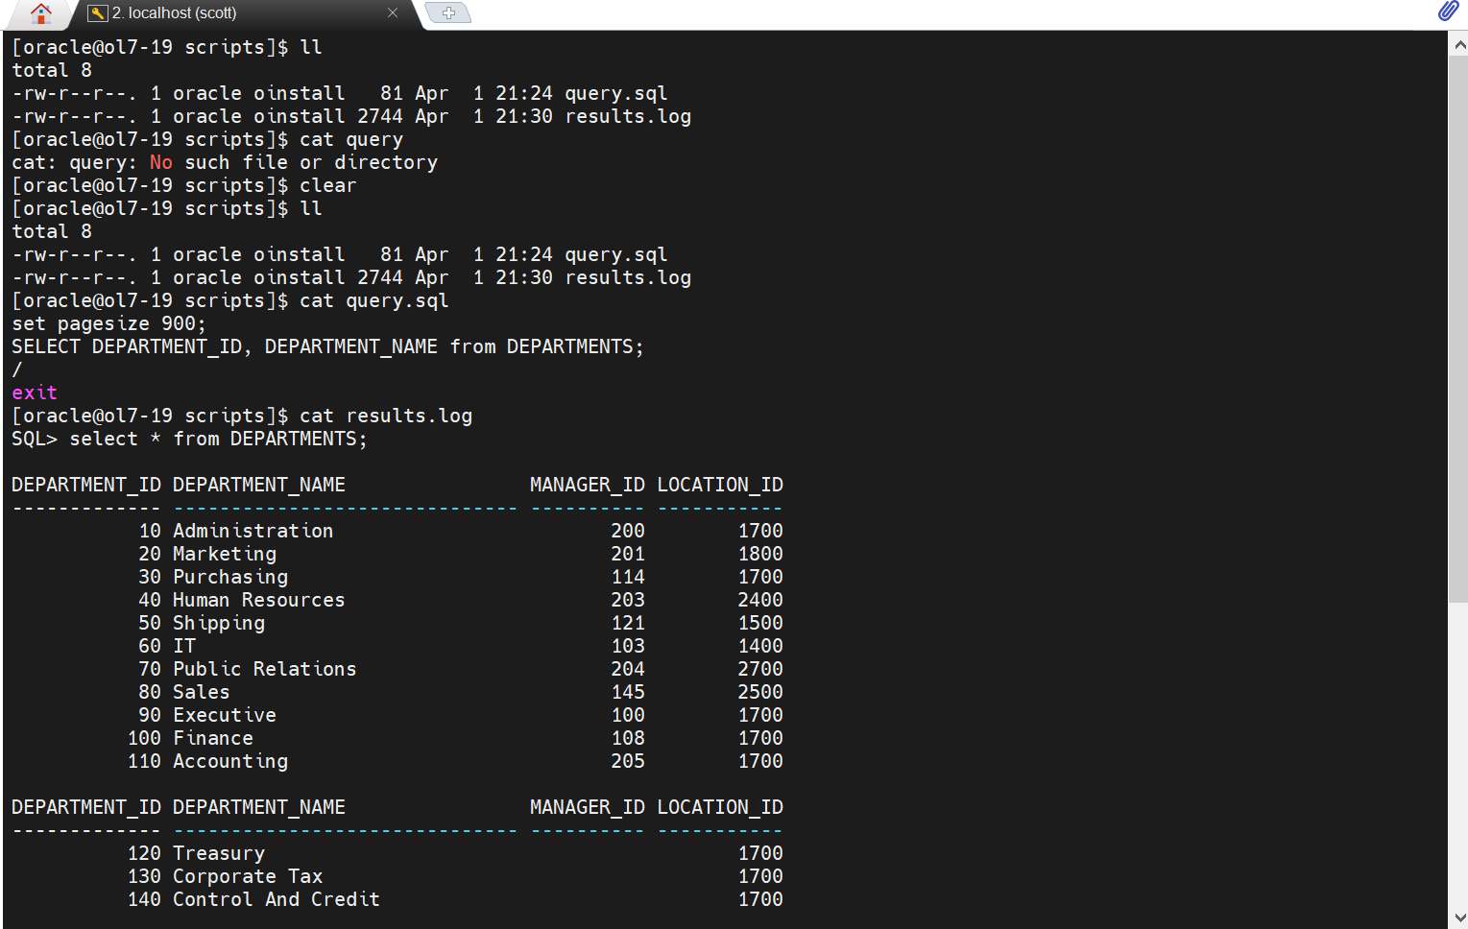

Figure . Query Select

# Lab 3. PDB Clone

Restore from the previous snapshot.

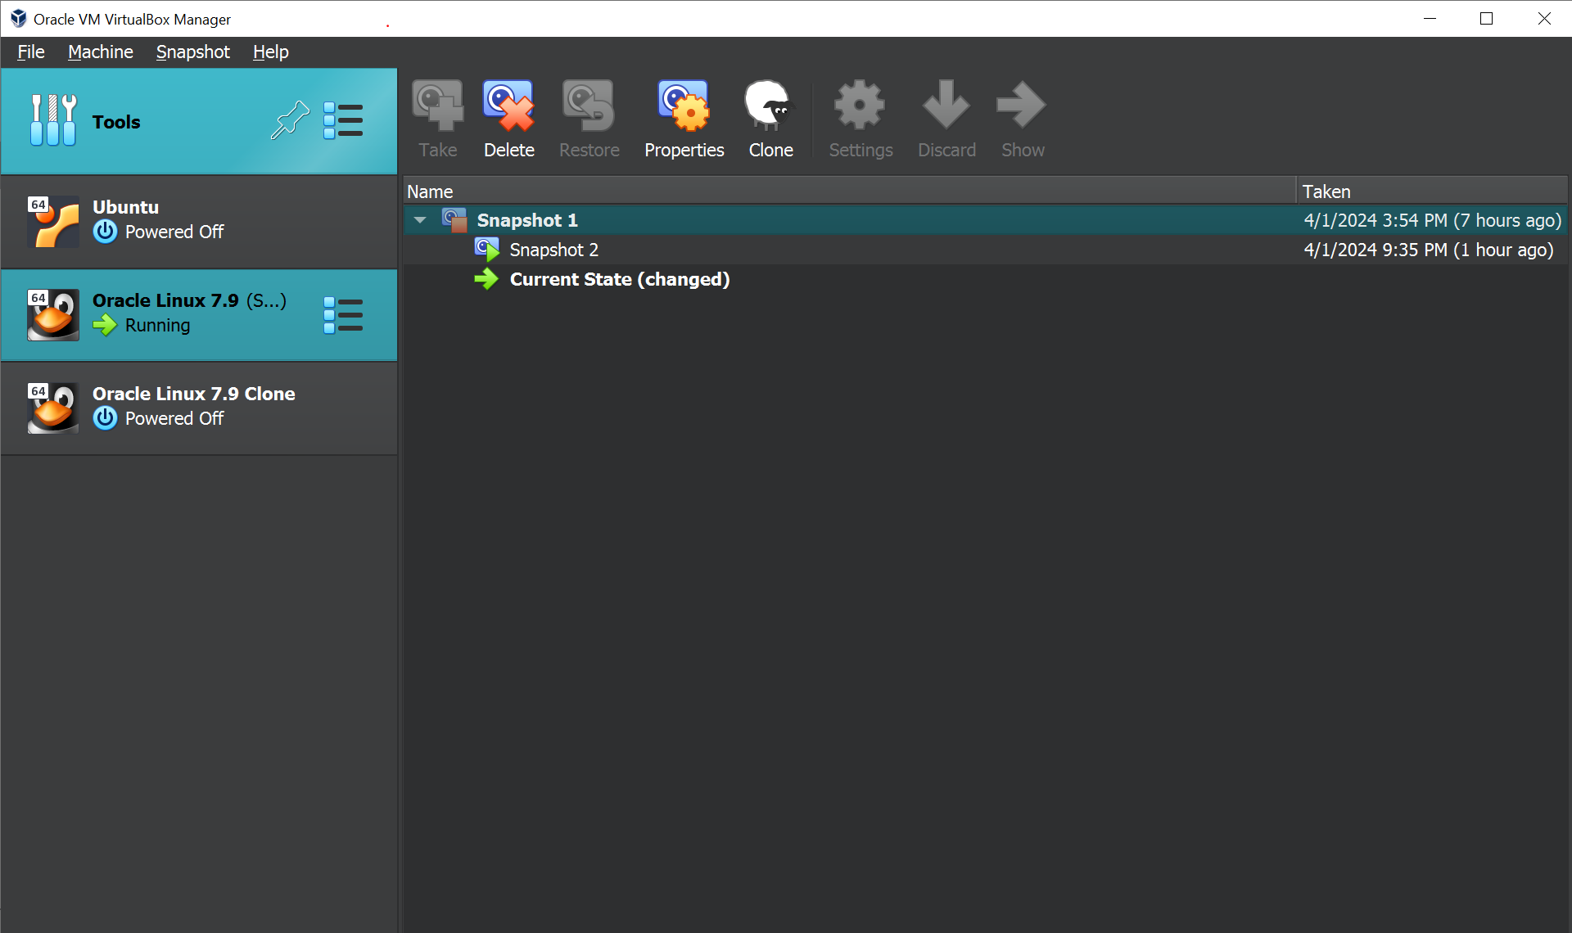

Figure . The previous snapshot

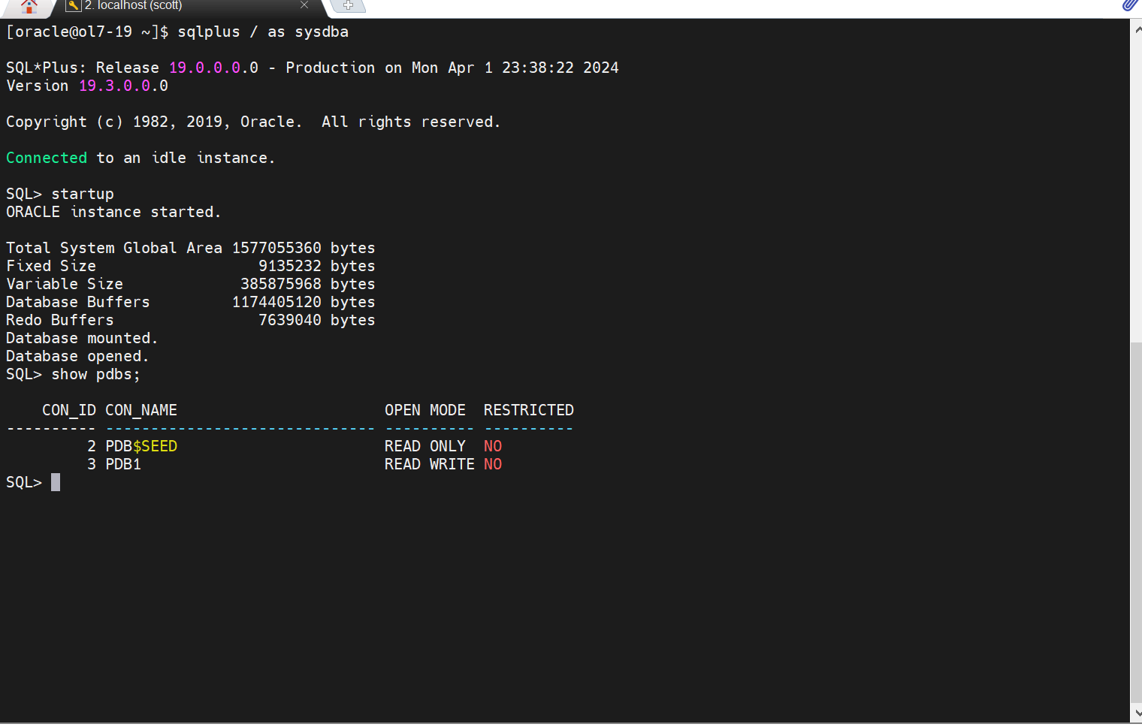

Figure . Pluggable Database

Clone Using SQL Developer by Click on “View”

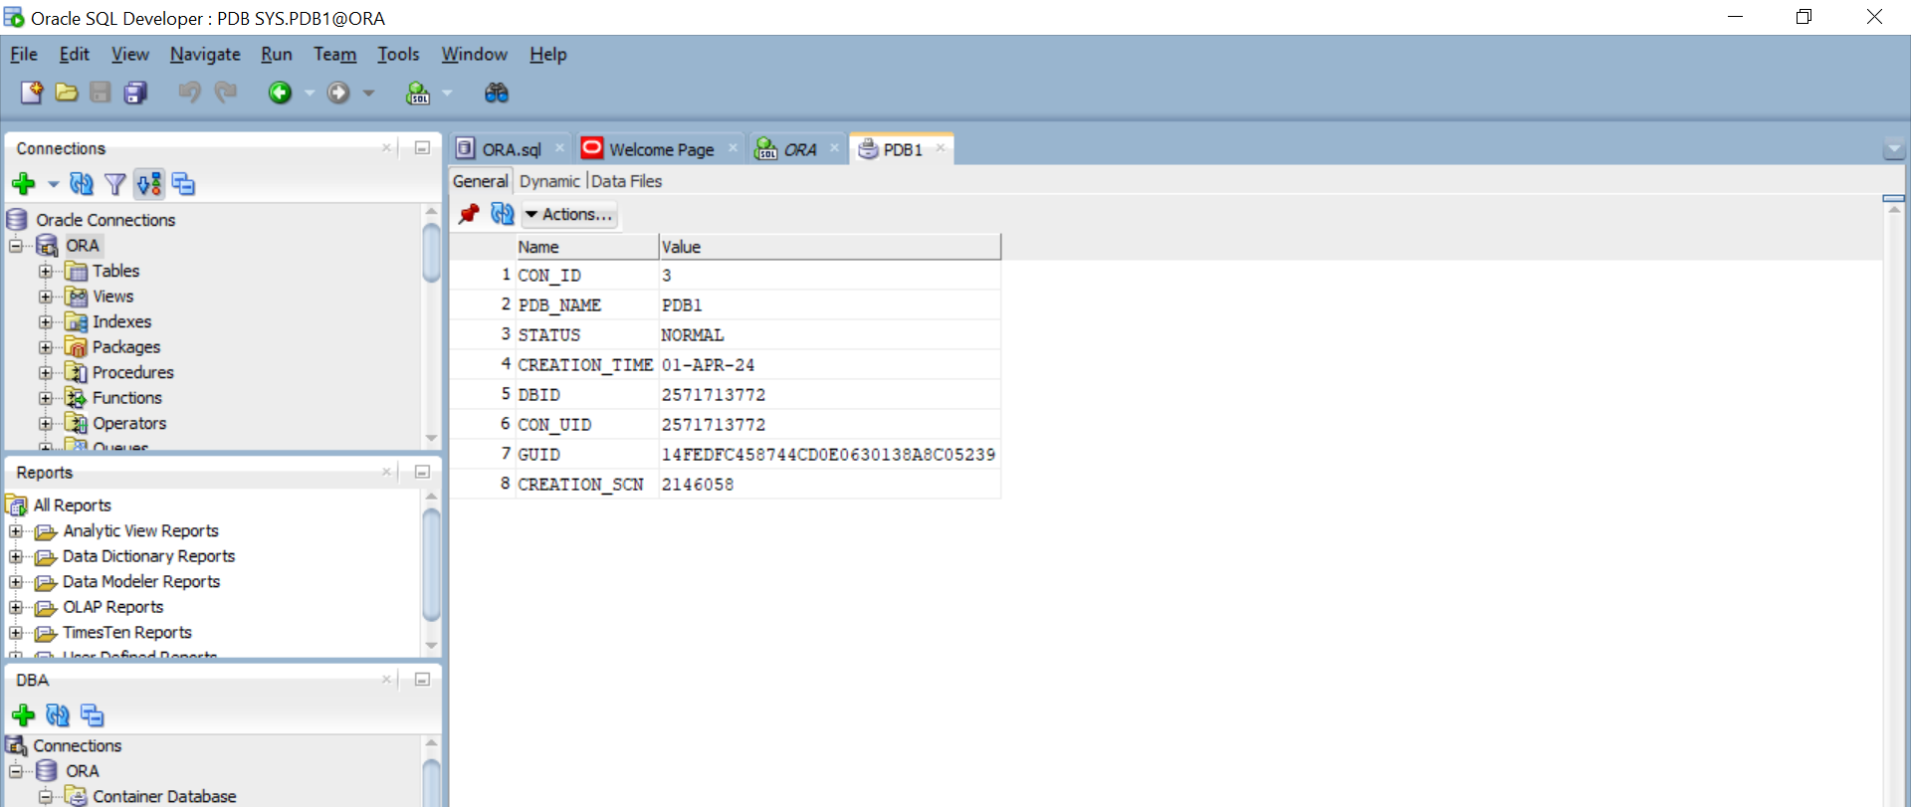

Click on “DBA”

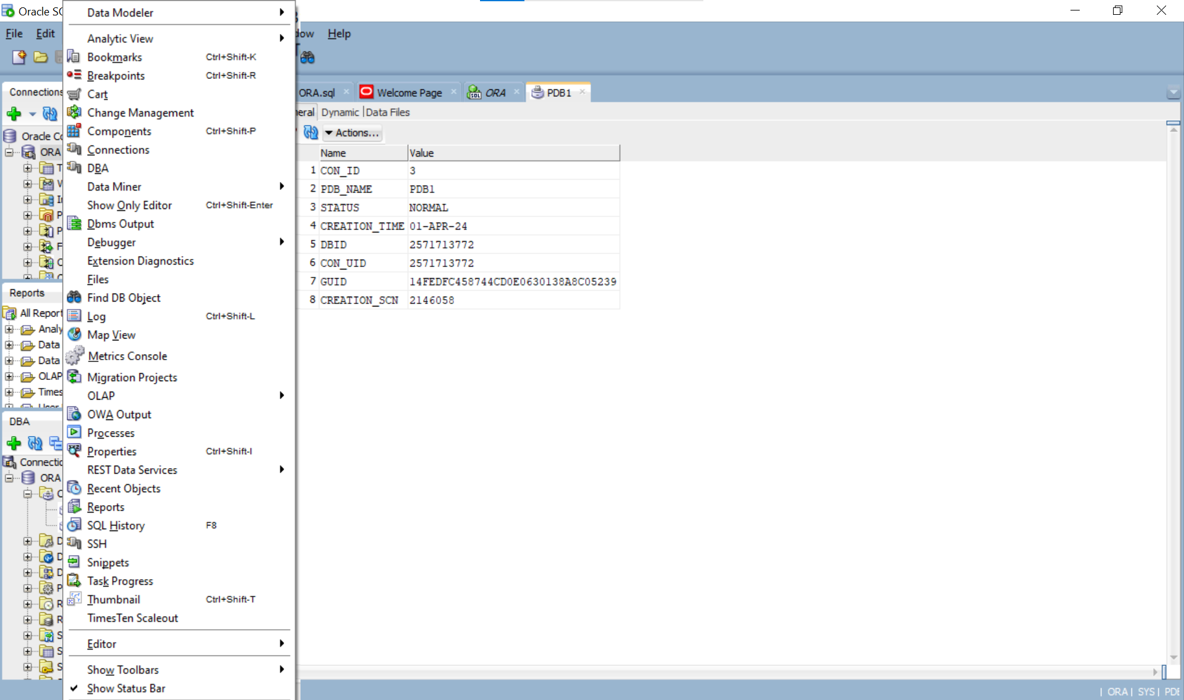

Extent Container Database and Right Click on “PDB1” then Clone PDB

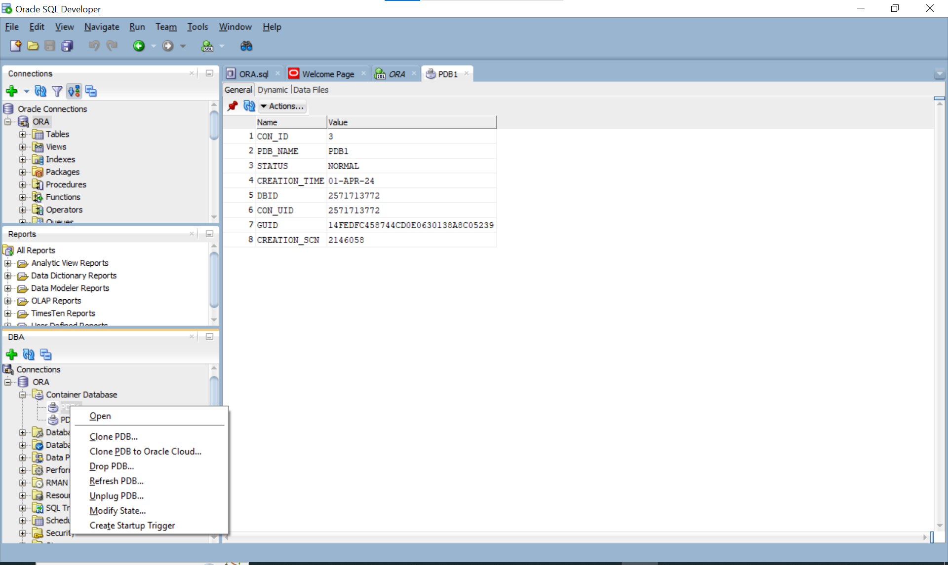

Now We Clone PDB successfully.

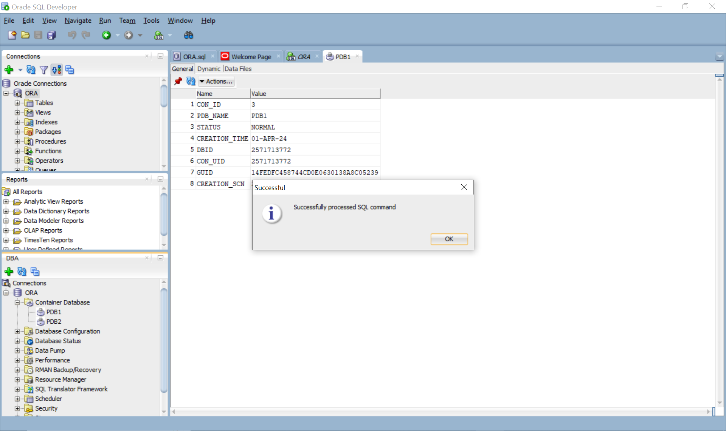

Add tns entry to tnsnames.ora





Add new connection to test in SQL Developer

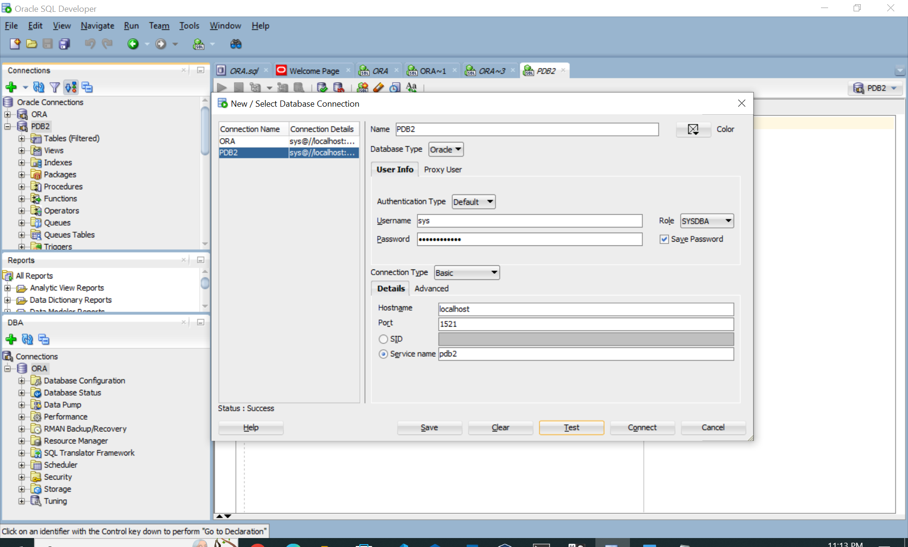

Show connection name.

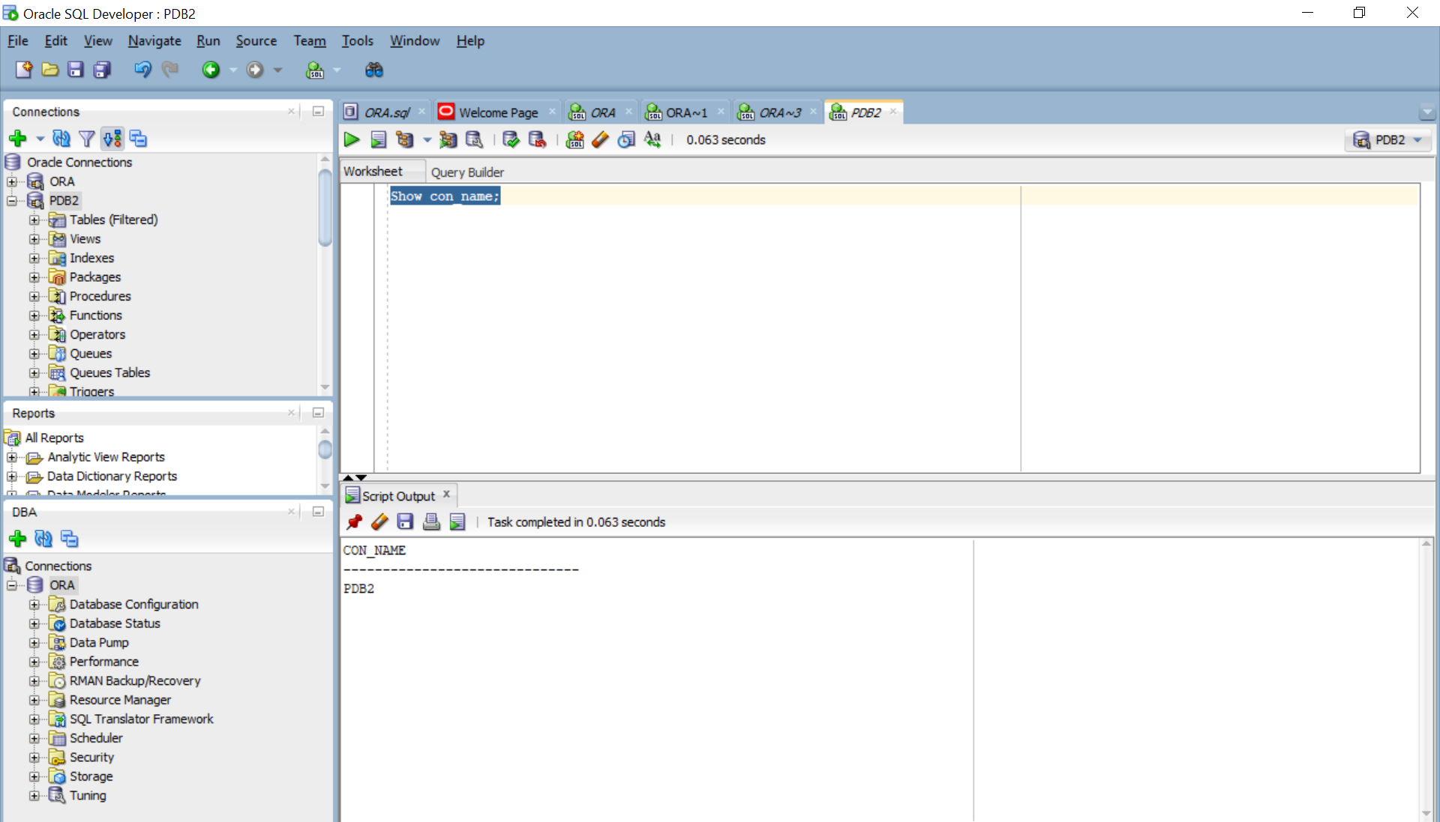

# **Lab 4. Tablespace + RAM**

Check default tablespace of PDB2.

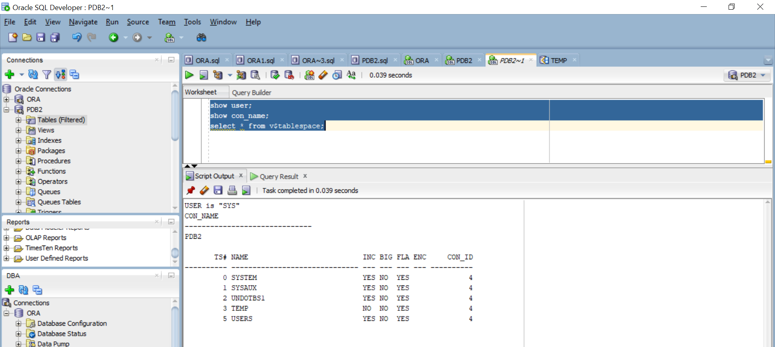

View as DBA

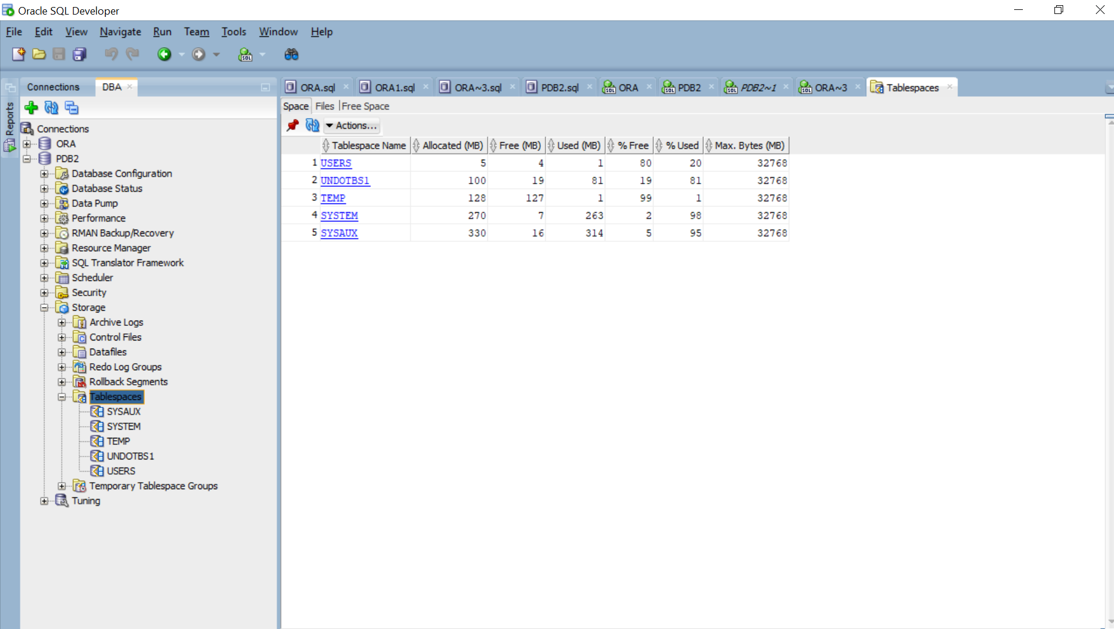

Create new tablespace using SQL Developer

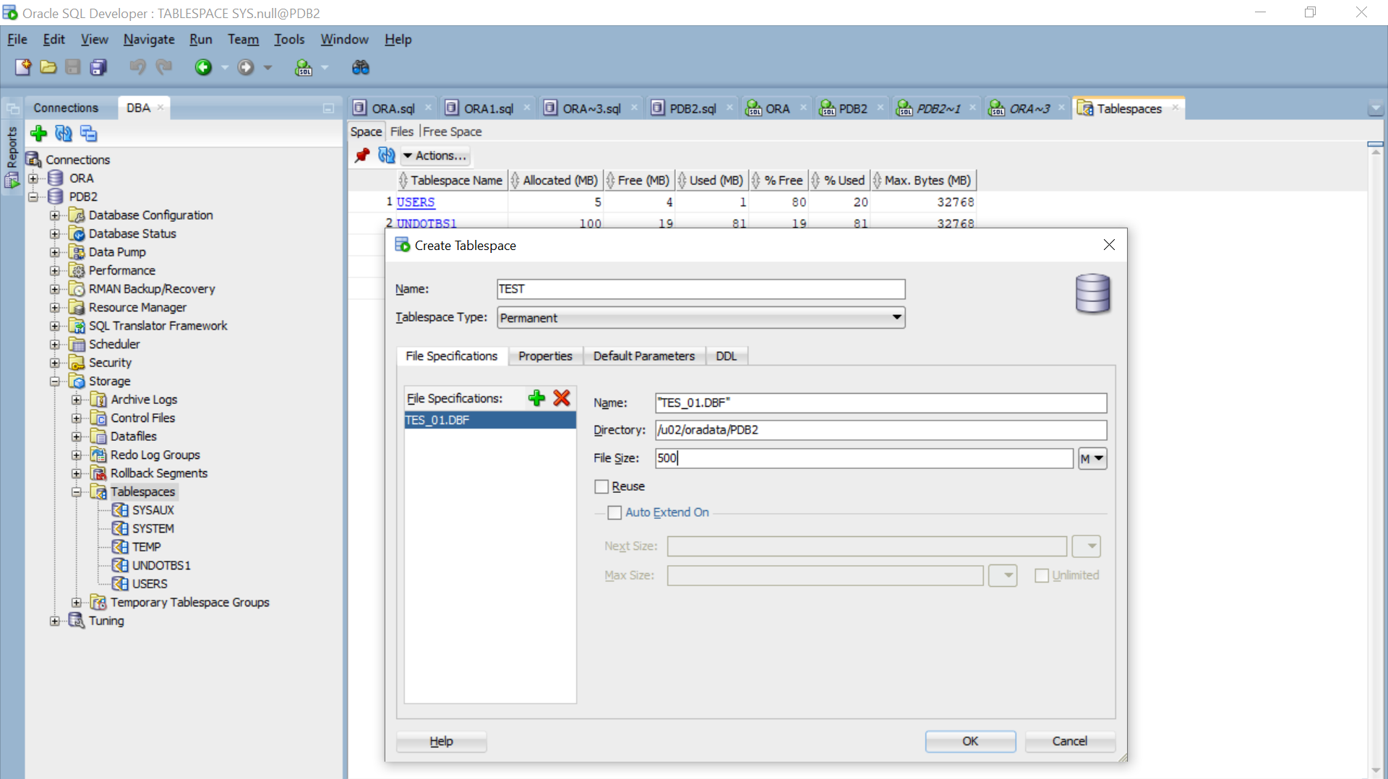

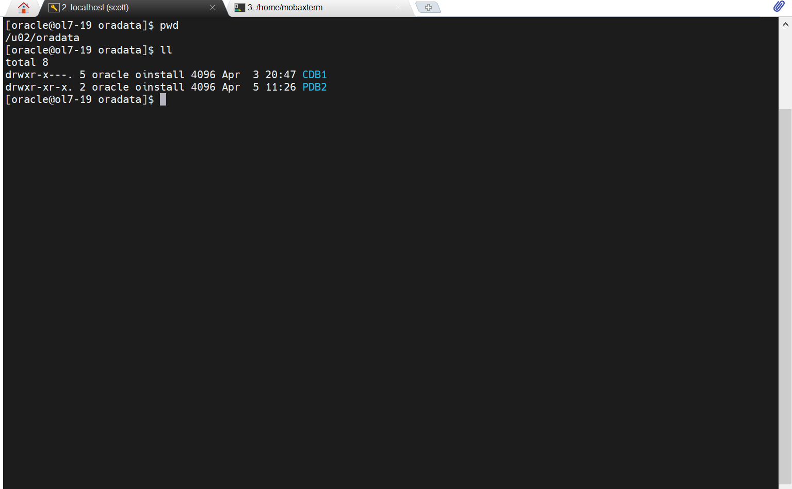

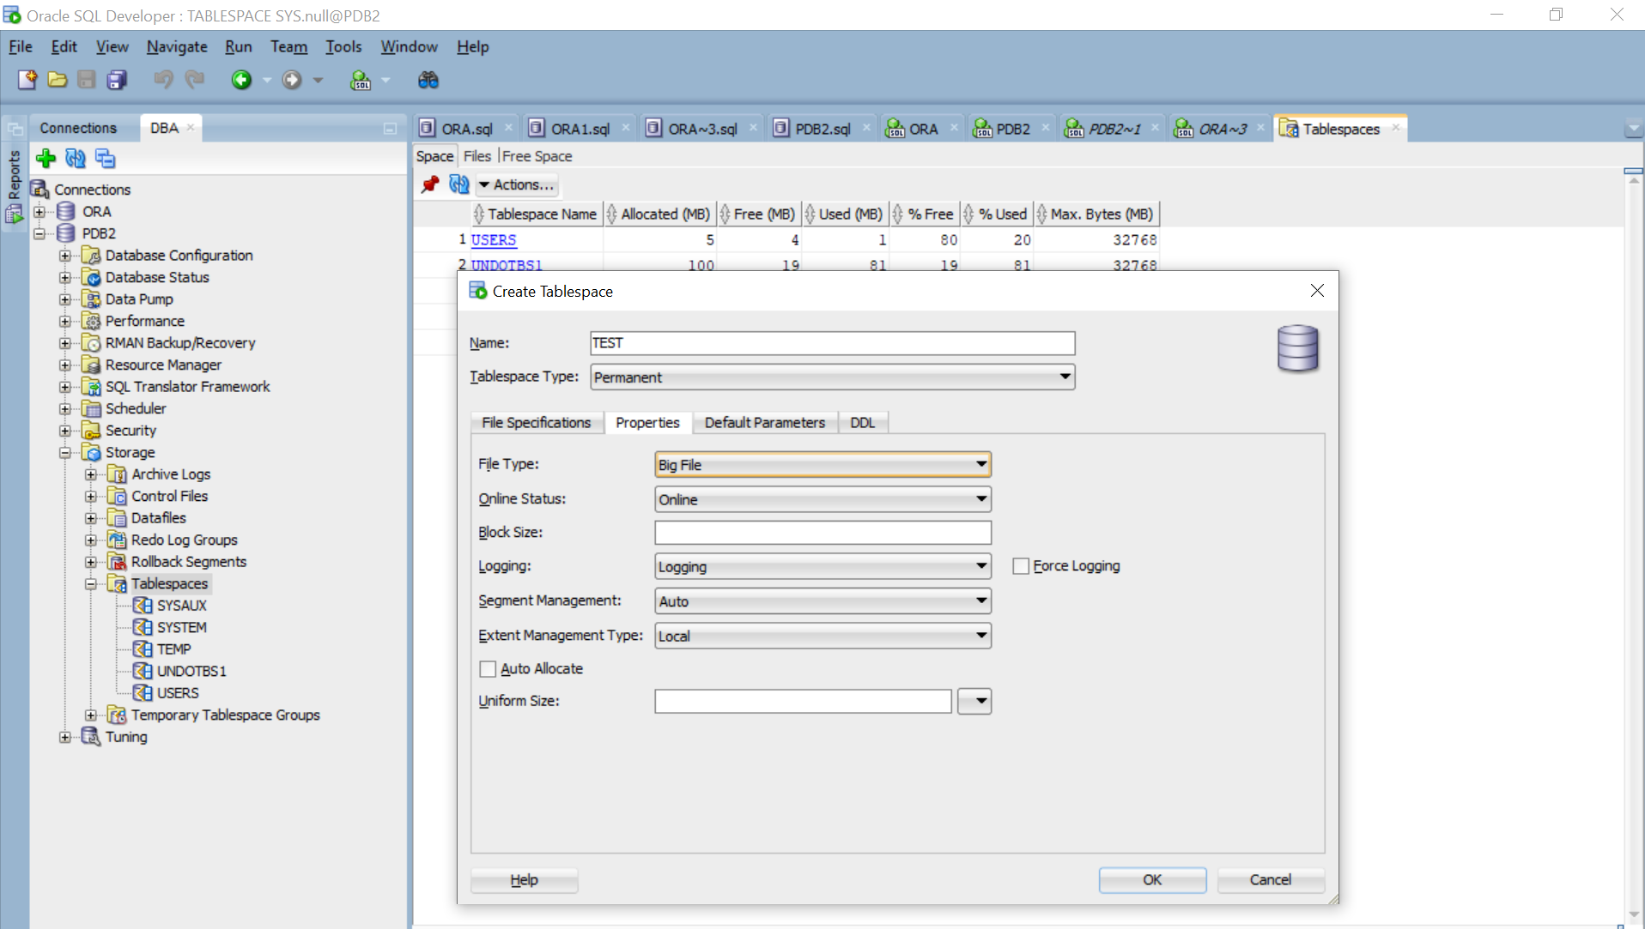

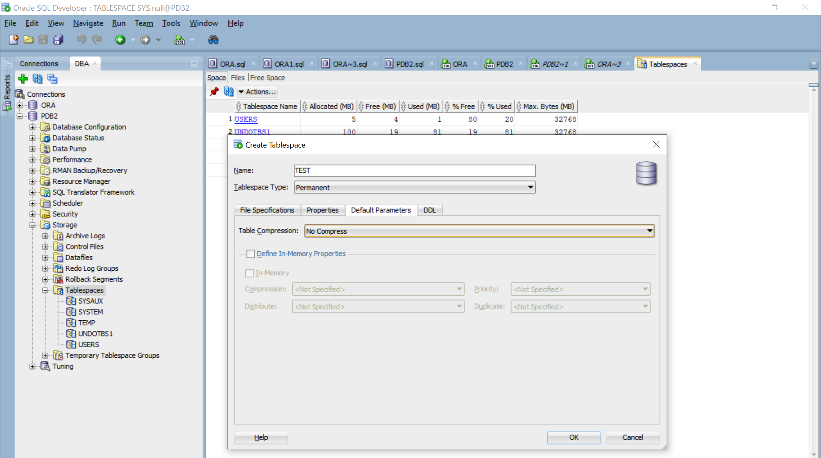

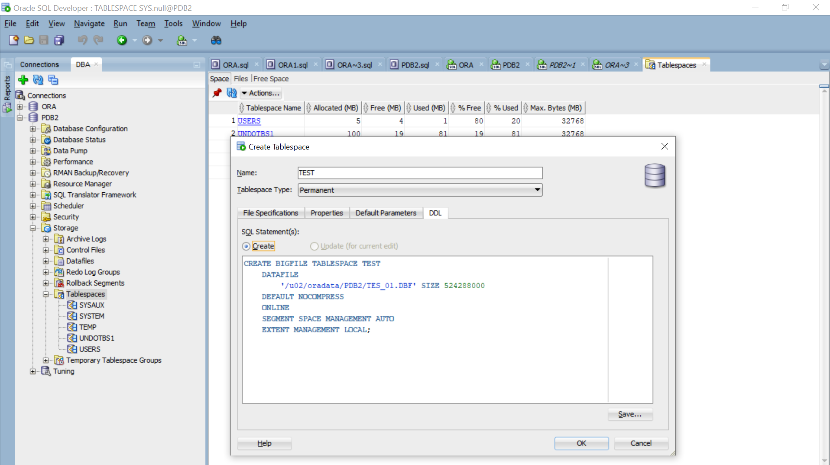

Click On Ok

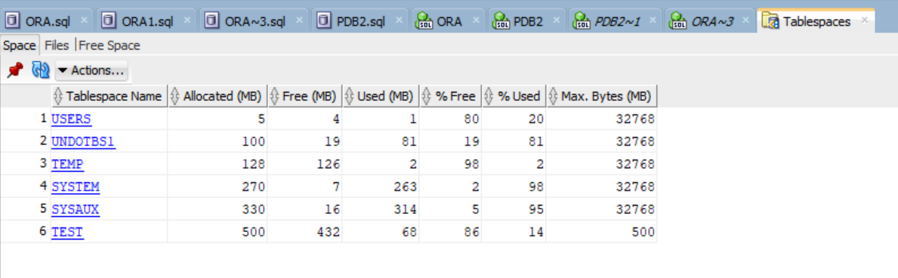

Create a user and assign tablespace to the user.

CREATE USER PDB2 IDENTIFIED BY PDB2 DEFAULT TABLESPACE TEST;

GRANT CREATE SESSION, CREATE TABLE, UNLIMITED TABLESPACE TO PDB2;

CREATE TABLE PDB2.TEST(N NUMBER);

SELECT * FROM DBA_TABLES WHERE OWNER ='PDB2';

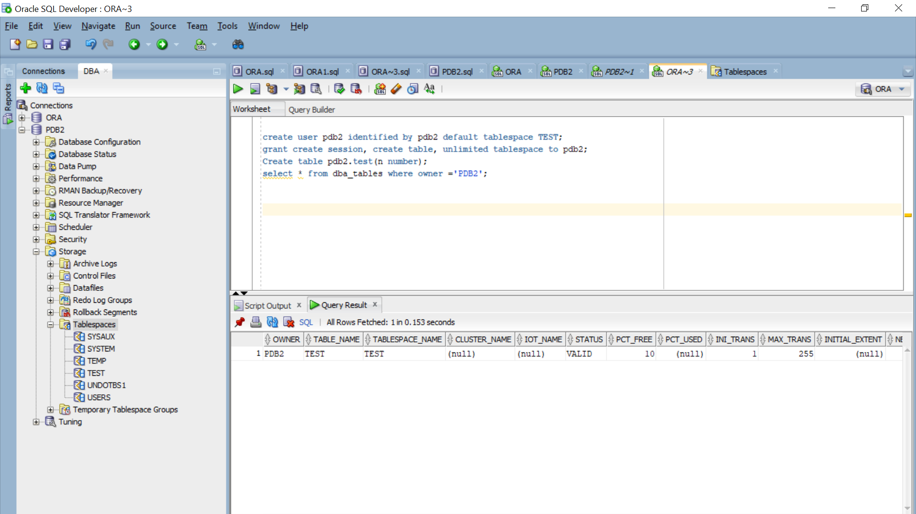

# **Lab 5. User Creation**

Basic syntax:

CREATE USER username

    IDENTIFIED BY password

    [DEFAULT TABLESPACE tablespace]

    [QUOTA {size | UNLIMITED} ON tablespace]

    [PROFILE profile]

    [PASSWORD EXPIRE]

    [ACCOUNT {LOCK | UNLOCK}];

*Example 1:*

CREATE USER Bunthoeurn

    IDENTIFIED BY Passw0rd

    DEFAULT TABLESPACE TEST

    QUOTA UNLIMITED ON TEST

    ACCOUNT UNLOCK;

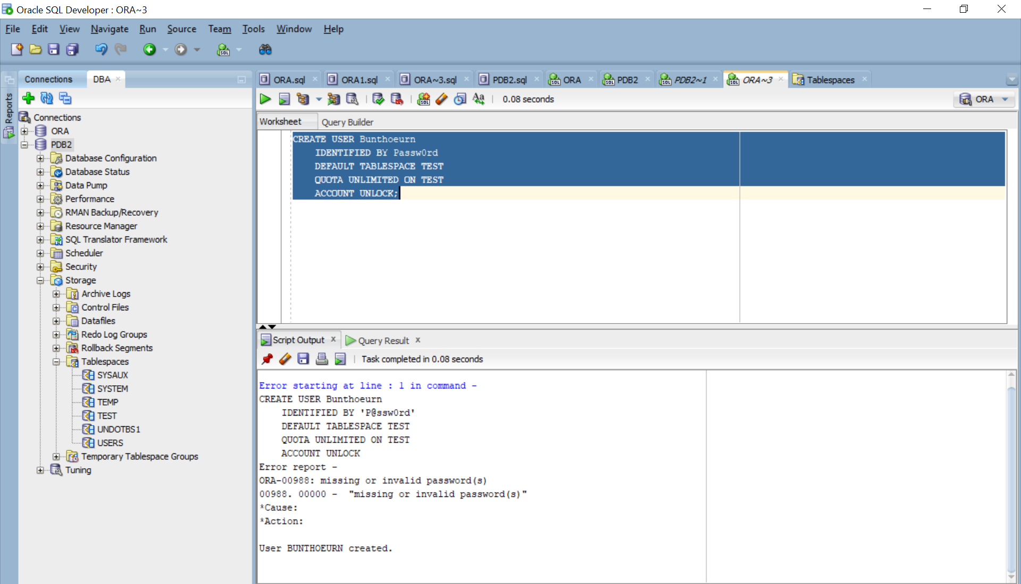

SELECT

    username,

    default_tablespace,

    profile,

    authentication_type

FROM

    dba_users

WHERE

    account_status = 'OPEN';

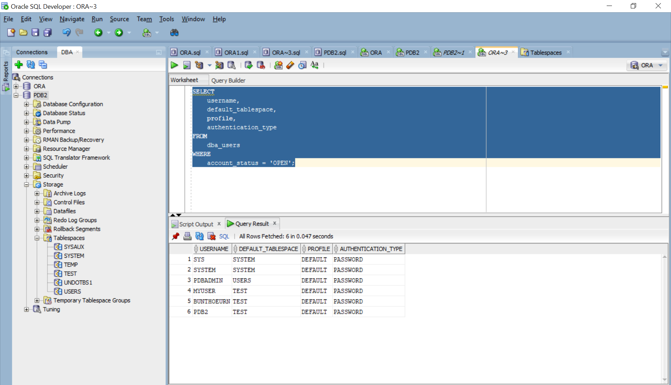

GRANT CREATE SESSION TO BUNTHOEURN;

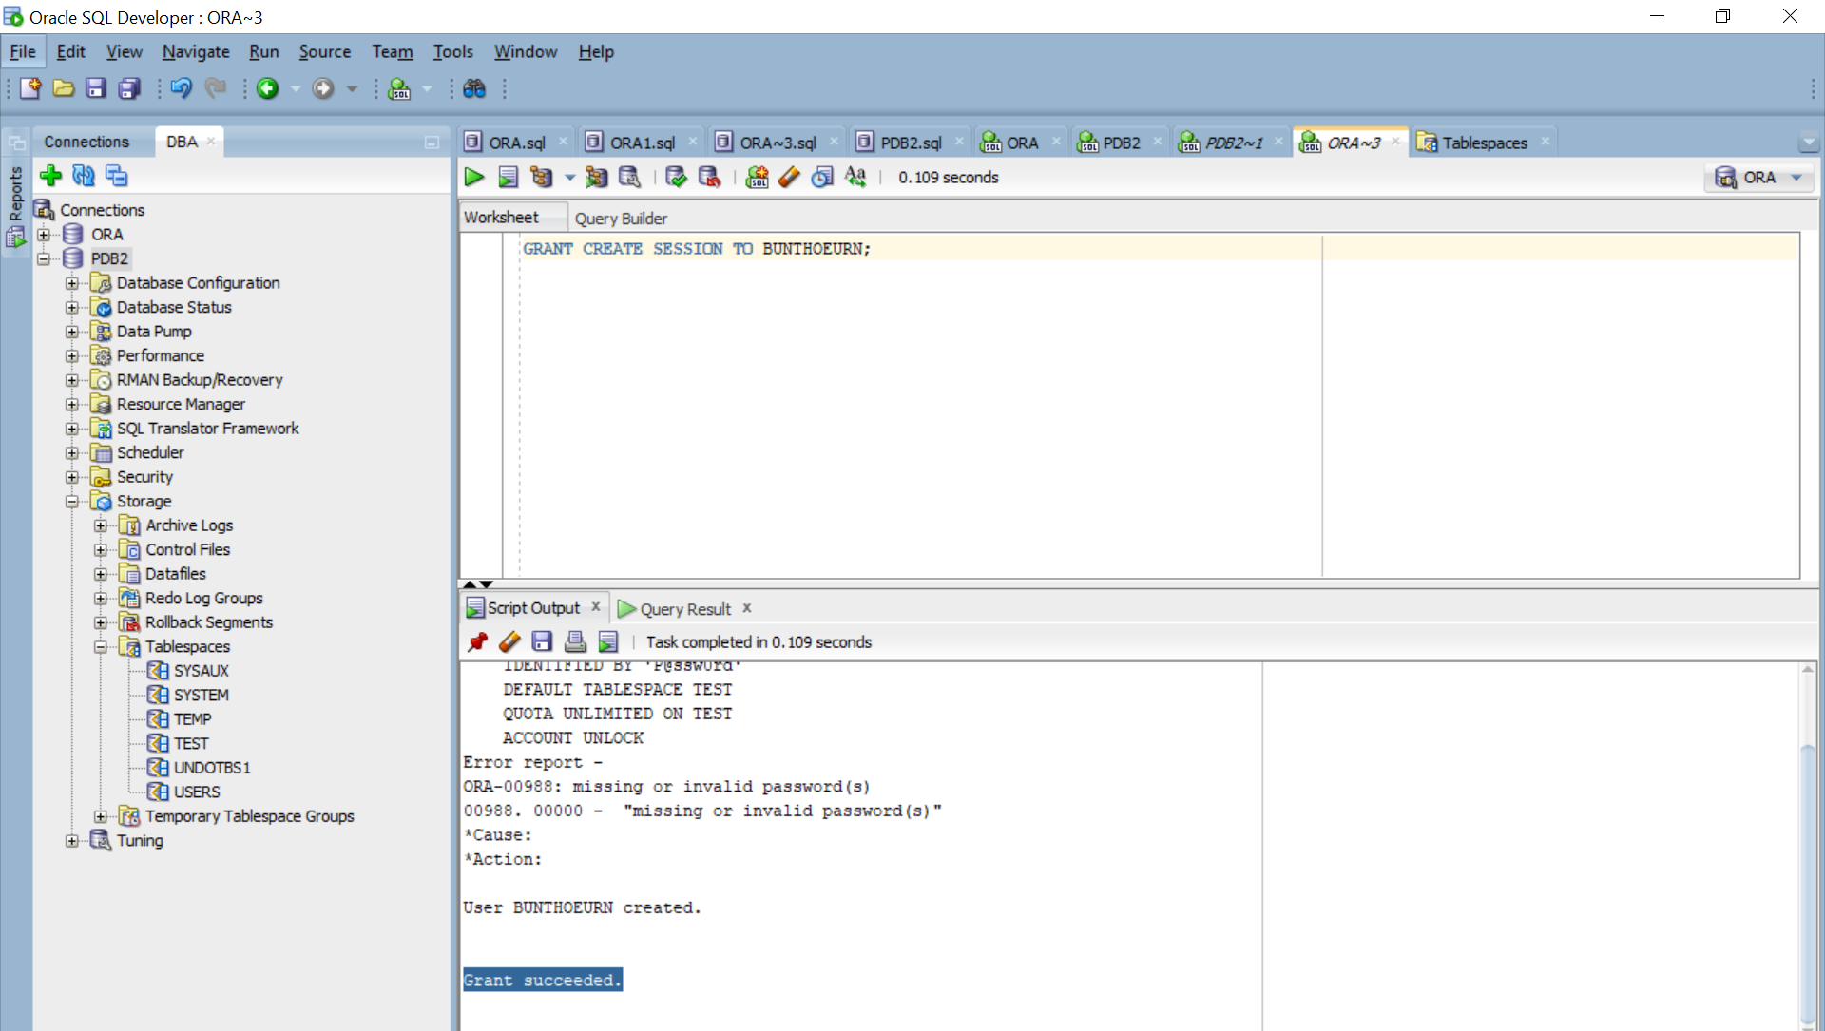

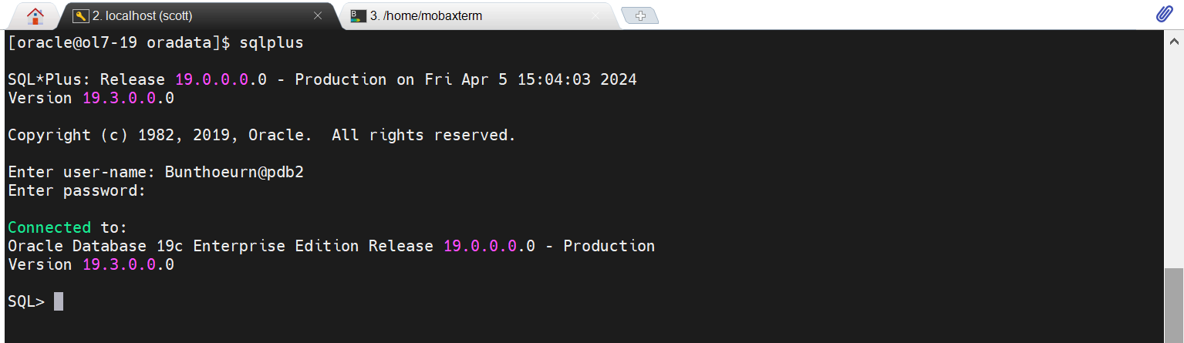

*Example 2:*

CREATE USER Bunthoeurn1

    IDENTIFIED BY Passw0rd

    DEFAULT TABLESPACE TEST

    QUOTA UNLIMITED ON TEST

    PASSWORD EXPIRE

    ACCOUNT UNLOCK;

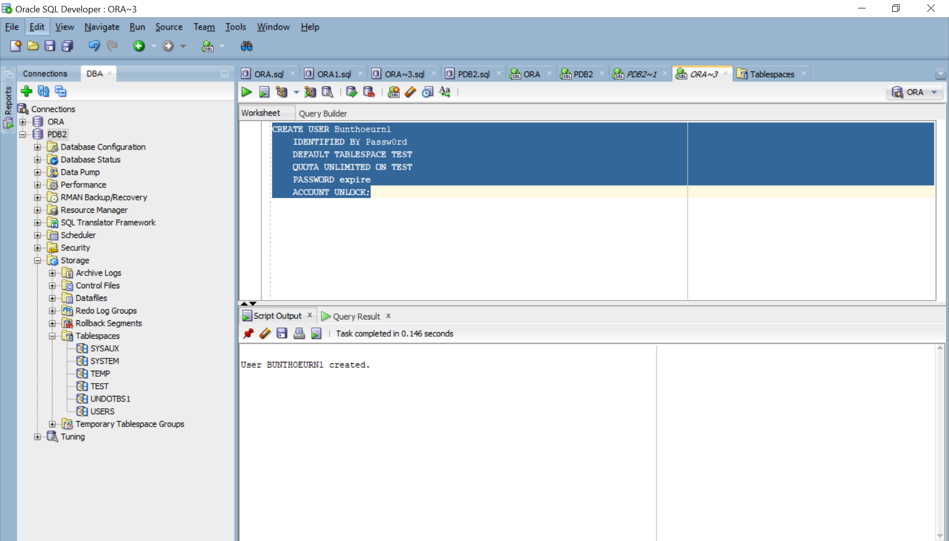

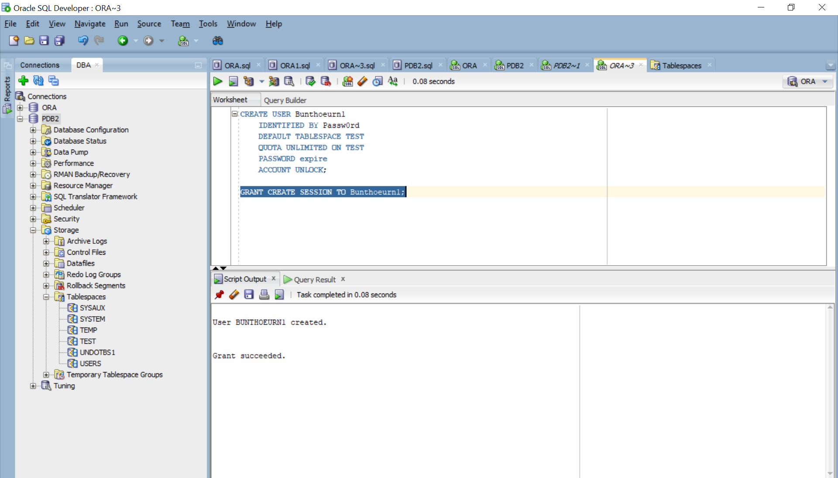

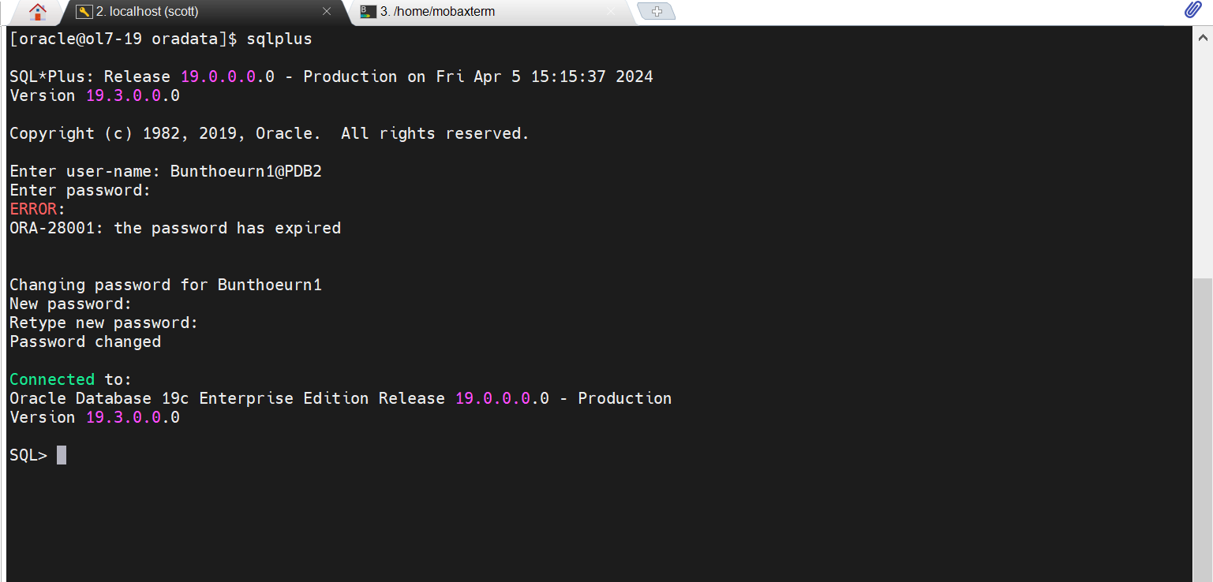

# **Lab 6: Move Segment**

# **Lab 7: User Role & Profile Policy**

Now we are working on PDB4.

[oracle@ol7-19 schema]$ cd $ORACLE_HOME/demo/schema/human_resources

[oracle@ol7-19 human_resources]$ clear

[oracle@ol7-19 human_resources]$ sqlplus / as sysdba

SQL*Plus: Release 19.0.0.0.0 - Production on Sat Apr 6 18:06:35 2024

Version 19.3.0.0.0

Copyright (c) 1982, 2019, Oracle. All rights reserved.

Connected to:

Oracle Database 19c Enterprise Edition Release 19.0.0.0.0 - Production

Version 19.3.0.0.0

SQL> show pdbs

CON_ID CON_NAME OPEN MODE RESTRICTED

---------- ------------------------------ ---------- ----------

2 PDB$SEED READ ONLY NO

3 PDB3 MOUNTED

4 PDB4 READ WRITE NO

SQL> alter session set container = PDB4;

Session altered.

SQL> @hr_main.sql

Then input value:

1 value=hr

2 value=user

3 value=temp

4 value= $ORACLE_HOME/demo/schema/log

Go to login on SQL developer:

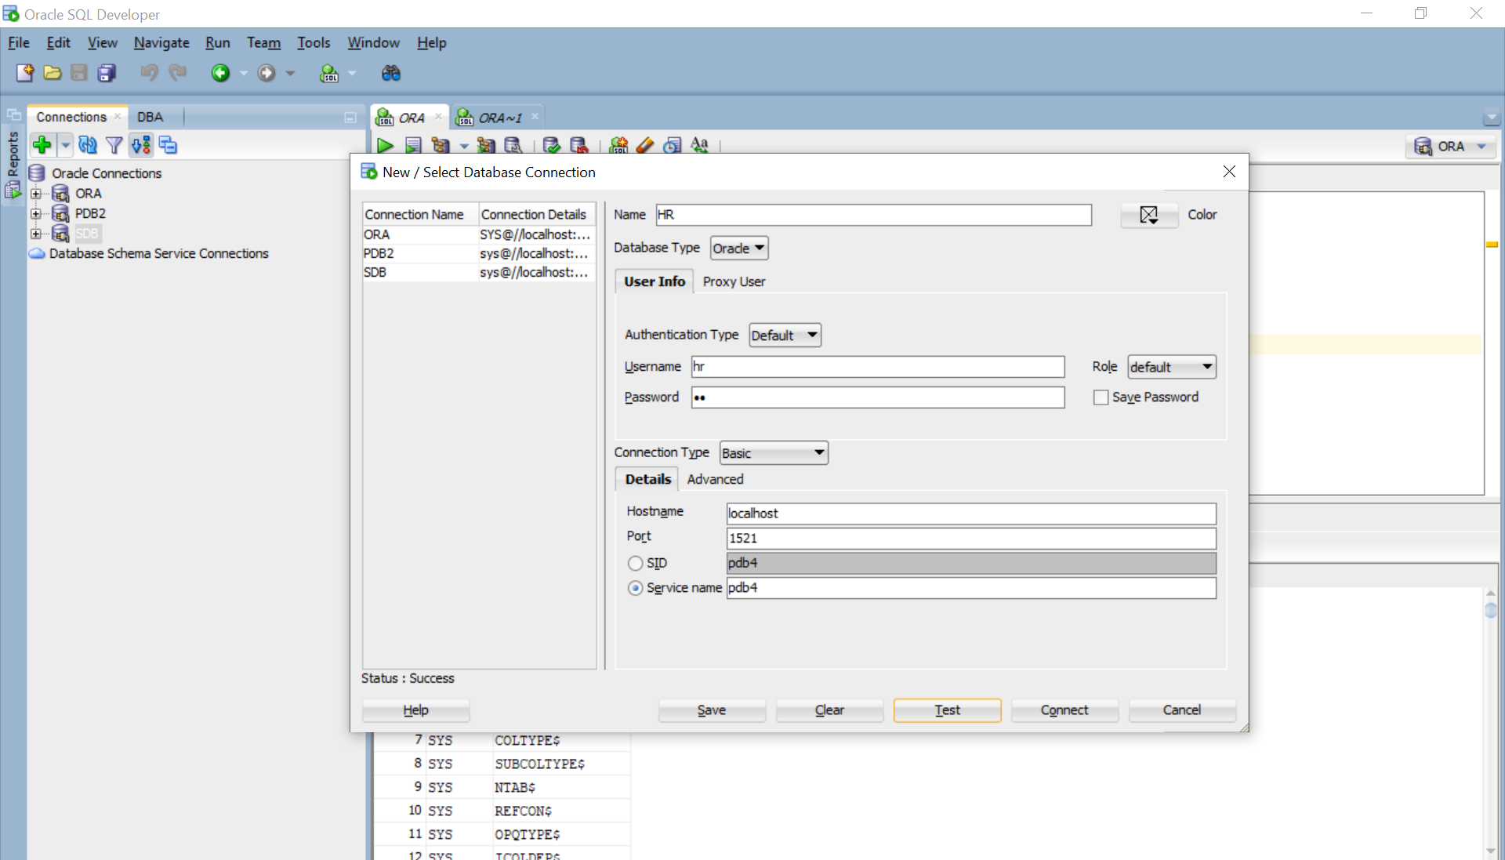

Figure . Connect to database

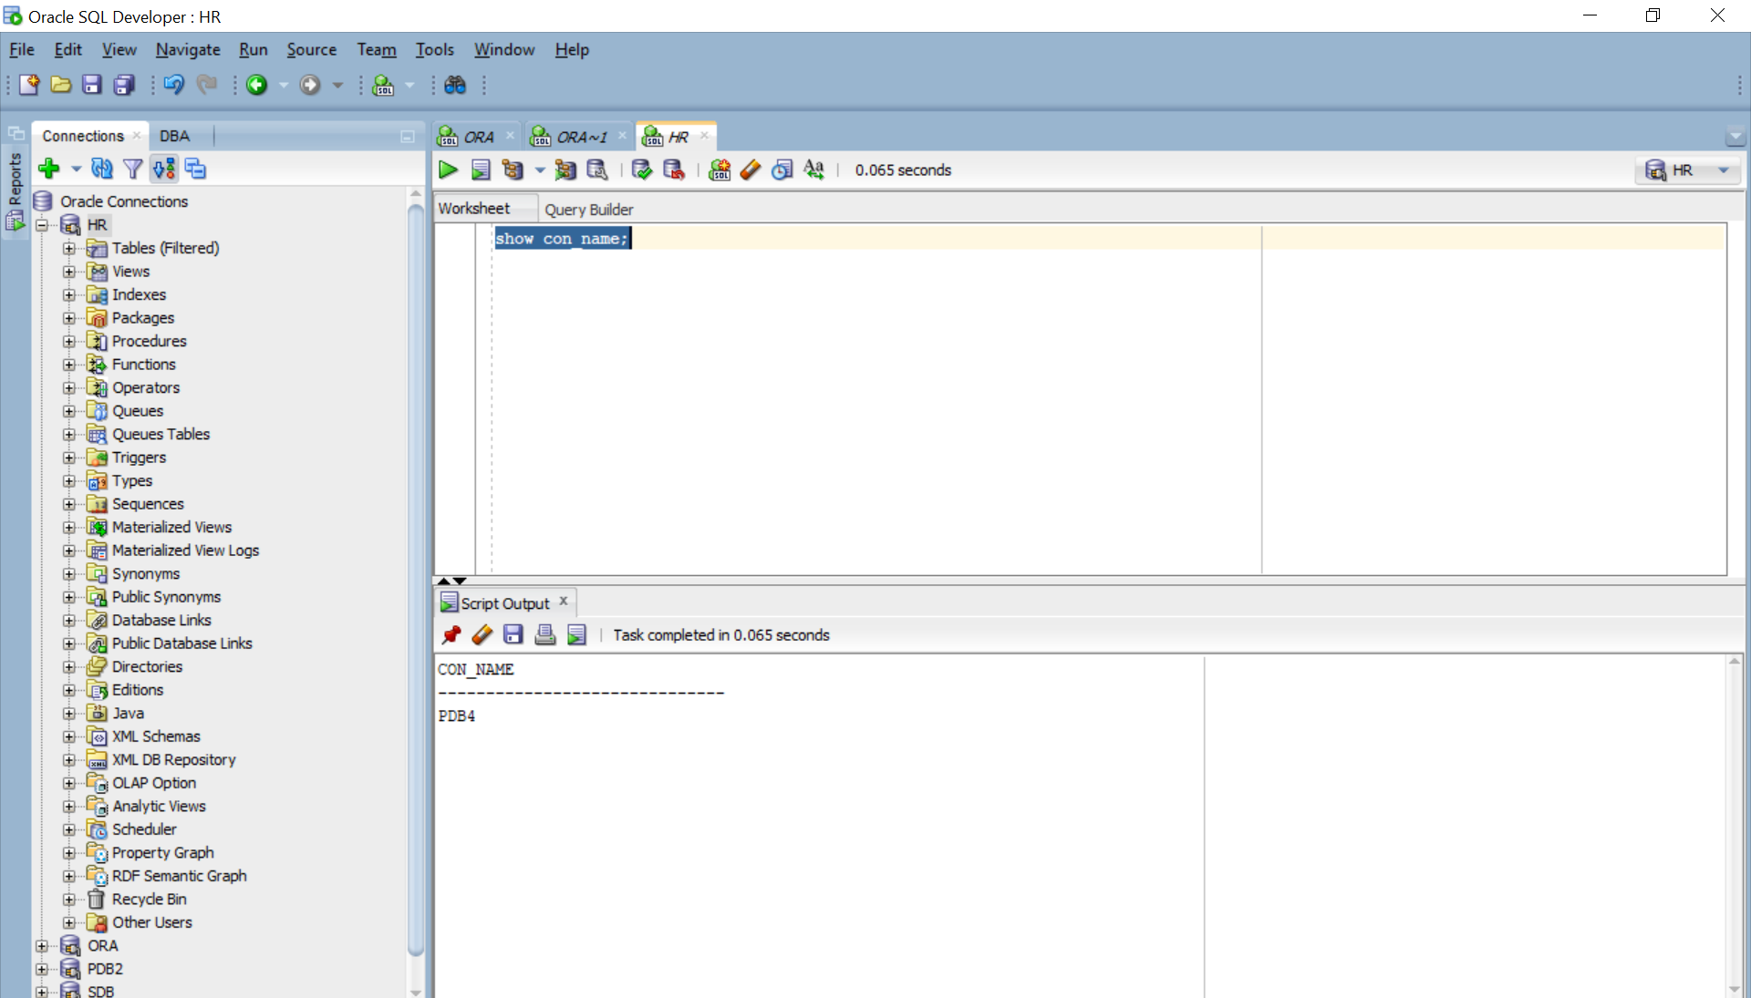

Figure . Connect to database

Show all privileges.

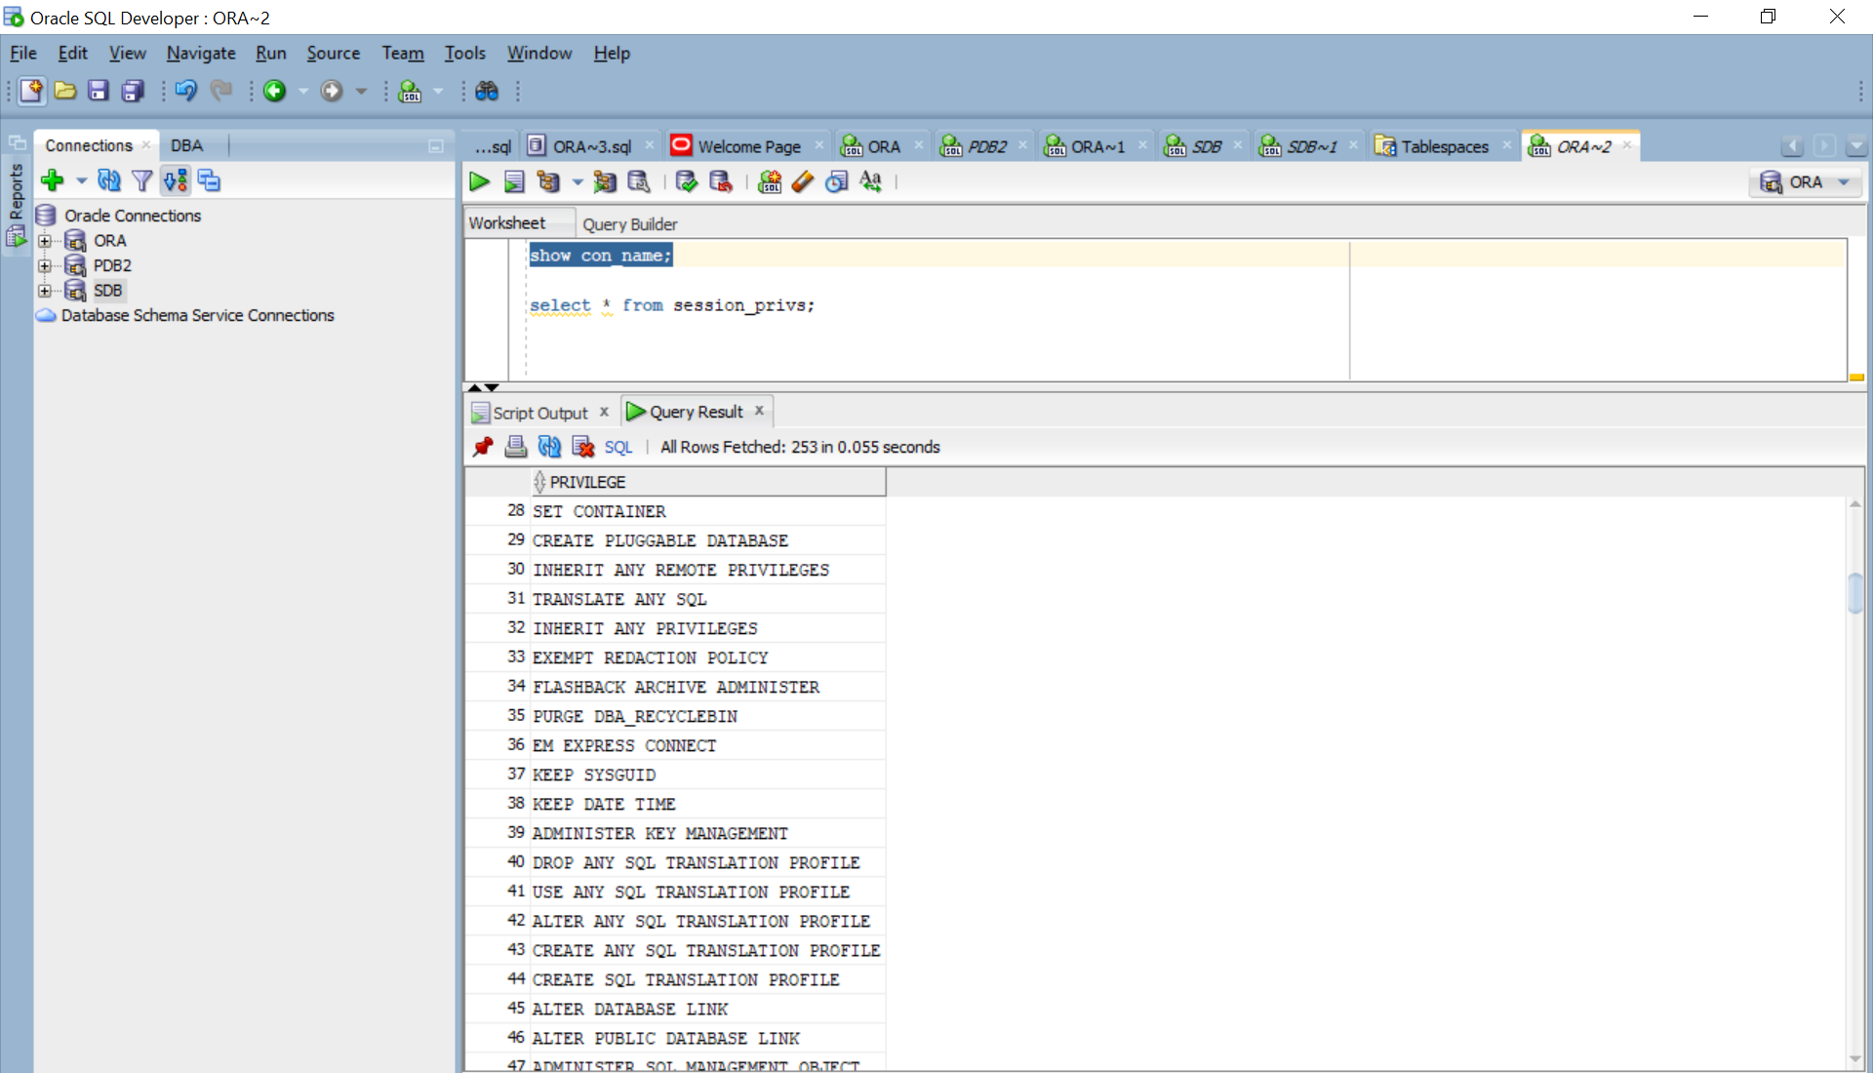

Figure . Show all privileges

Let’s dev into create user roles base on Figure 2 below.

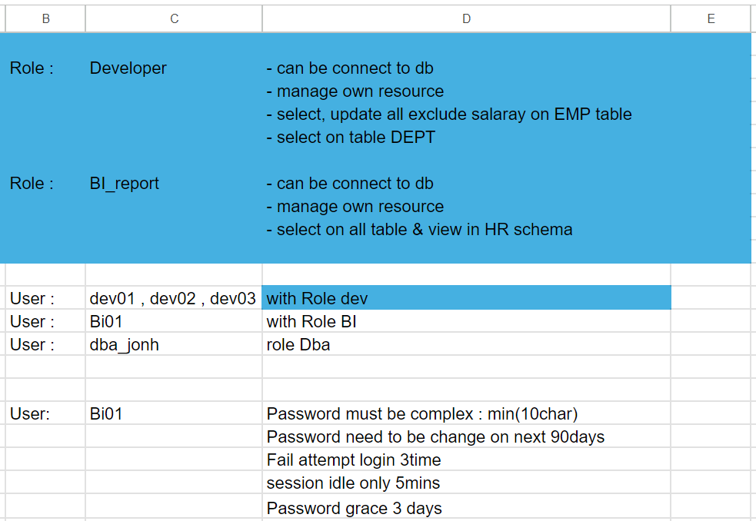

Figure . User Role and Profile Policy

[oracle@ol7-19 human_resources]$ sqlplus / as sysdba

SQL*Plus: Release 19.0.0.0.0 - Production on Sat Apr 6 18:14:21 2024

Version 19.3.0.0.0

Copyright (c) 1982, 2019, Oracle.  All rights reserved.

Connected to:

Oracle Database 19c Enterprise Edition Release 19.0.0.0.0 - Production

Version 19.3.0.0.0

SQL> Create role BI_report;

Create role BI_report

            *

ERROR at line 1:

ORA-65096: invalid common user or role name

SQL> alter session set container=PDB4;

Session altered.

SQL> CREATE ROLE BI_report;

Role created.

SQL> Create role Developer;

Role created.

SQL>

We also can go to SQL Developer to grant permission to **Developer**.

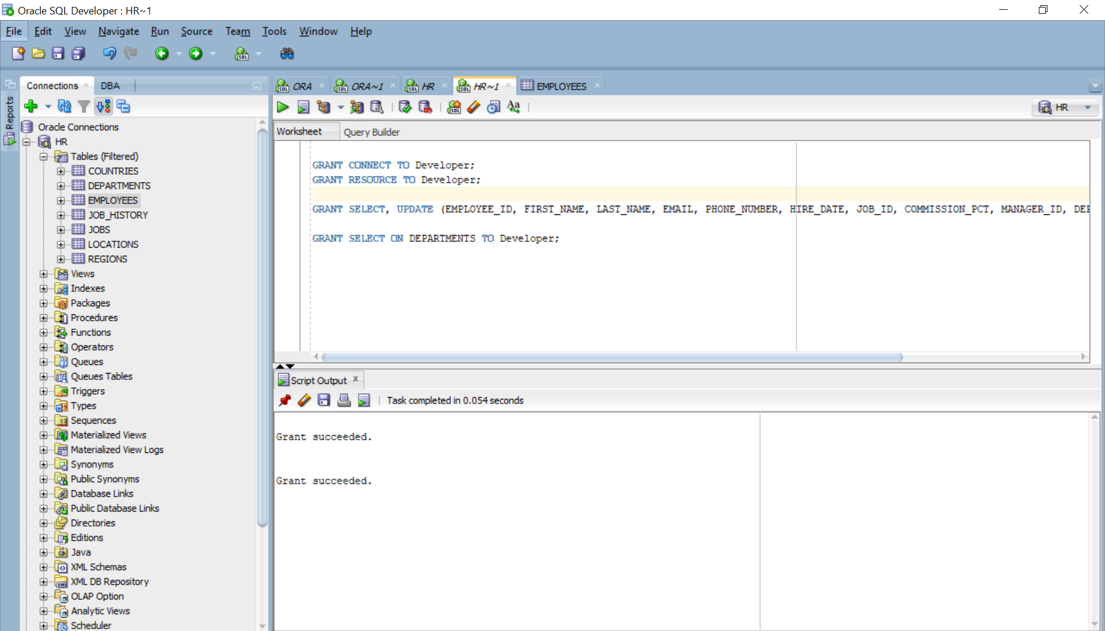

Figure . Grant permission to role Developer

GRANT CONNECT TO Developer;

GRANT RESOURCE TO Developer;

GRANT SELECT, UPDATE (EMPLOYEE_ID, FIRST_NAME, LAST_NAME, EMAIL, PHONE_NUMBER, HIRE_DATE, JOB_ID, COMMISSION_PCT, MANAGER_ID, DEPARTMENT_ID) ON EMPLOYEES TO Developer;

GRANT SELECT ON DEPARTMENTS TO Developer;

Grant permission to **BI_report**.

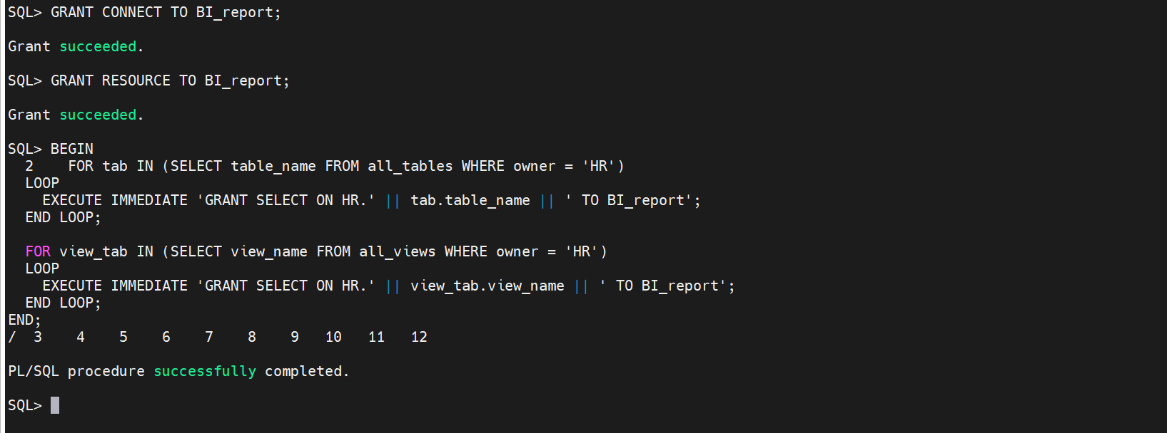

GRANT CONNECT TO BI_report;

GRANT RESOURCE TO BI_report;

BEGIN

  FOR tab IN (SELECT table_name FROM all_tables WHERE owner = 'HR')

  LOOP

    EXECUTE IMMEDIATE 'GRANT SELECT ON HR.' || tab.table_name || ' TO BI_report';

  END LOOP;

  FOR view_tab IN (SELECT view_name FROM all_views WHERE owner = 'HR')

  LOOP

    EXECUTE IMMEDIATE 'GRANT SELECT ON HR.' || view_tab.view_name || ' TO BI_report';

  END LOOP;

END;

/

**Create user:**

User: **dev01 , dev02 , dev03** with role **Developer**

CREATE USER dev01 IDENTIFIED BY password01;

CREATE USER dev02 IDENTIFIED BY password02;

CREATE USER dev03 IDENTIFIED BY password03;

GRANT Developer TO dev01;

GRANT Developer TO dev02;

GRANT Developer TO dev03;

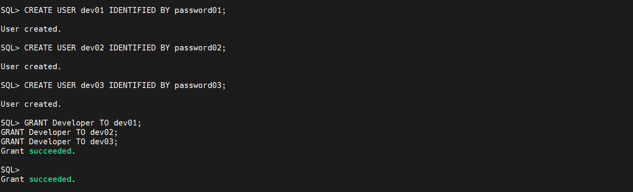

Figure . Assign permission

User**: Bi01**

CREATE USER Bi01 IDENTIFIED BY password01;

GRANT BI_report TO Bi01;

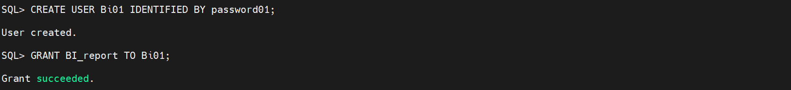

Figure . Assign permission

User: **dba_jonh** role **DBA**

CREATE USER dba_jonh IDENTIFIED BY password01;

GRANT SYSDBA TO dba_jonh;

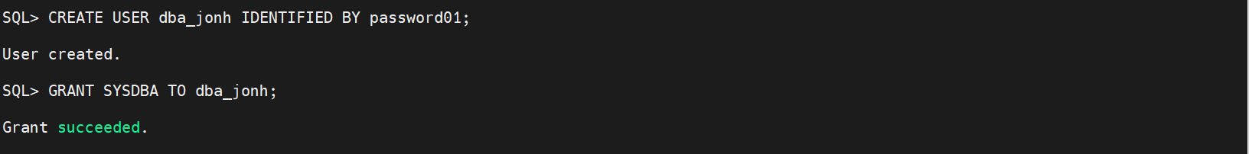

Figure . Assign permission

**Profile Policy user “Bi01**”

* Password must be complex : min(10char)
* Fail attempt login 3time
* session idle only 5mins
* Password grace 3 days

CREATE PROFILE bi_user_profile LIMIT

  PASSWORD_LIFE_TIME 90

  FAILED_LOGIN_ATTEMPTS 3

  PASSWORD_GRACE_TIME 3

  IDLE_TIME 5;

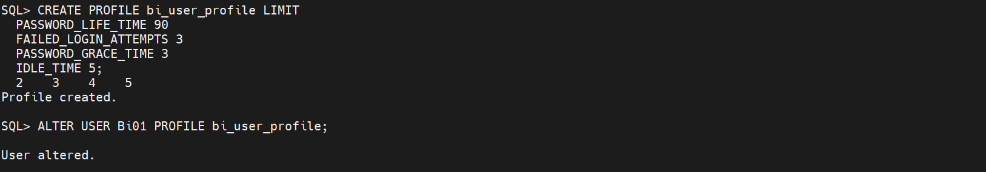

Figure . Apply profile

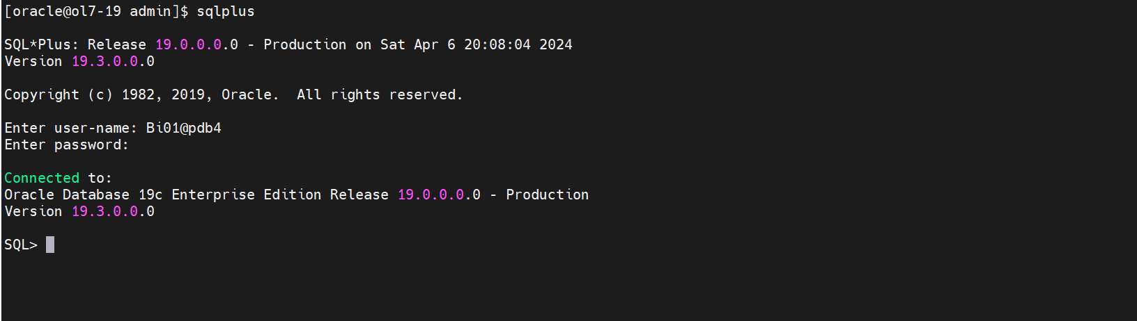

Figure . Try to login

**Complex password**

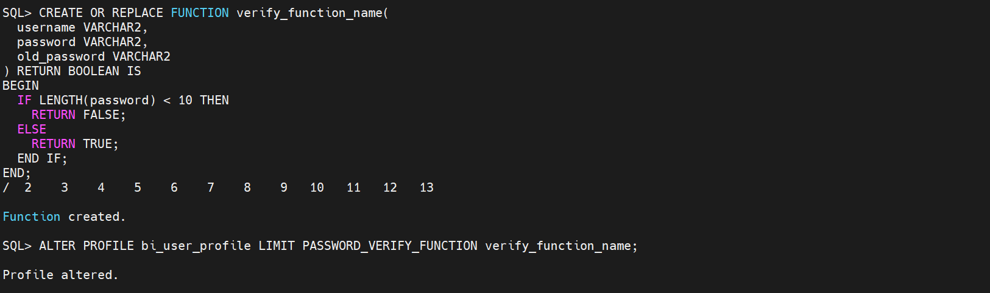

Figure . Apply complexity password

CREATE OR REPLACE FUNCTION verify_function_name(

  username VARCHAR2,

  password VARCHAR2,

  old_password VARCHAR2

) RETURN BOOLEAN IS

BEGIN

  IF LENGTH(password) < 10 THEN

    RETURN FALSE;

  ELSE

    RETURN TRUE;

  END IF;

END;

/

ALTER PROFILE bi_user_profile LIMIT PASSWORD_VERIFY_FUNCTION verify_function_name;

**Now force user to reset password**

ALTER USER Bi01 PASSWORD EXPIRE;

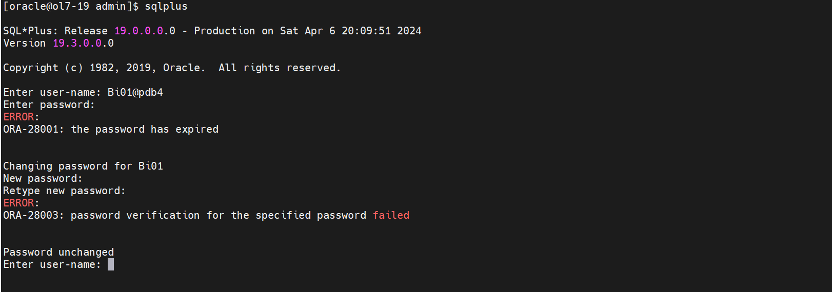

Figure . Check Result

# **Lab 8: User OS/Password File**

useradd osuser

passwd osuser

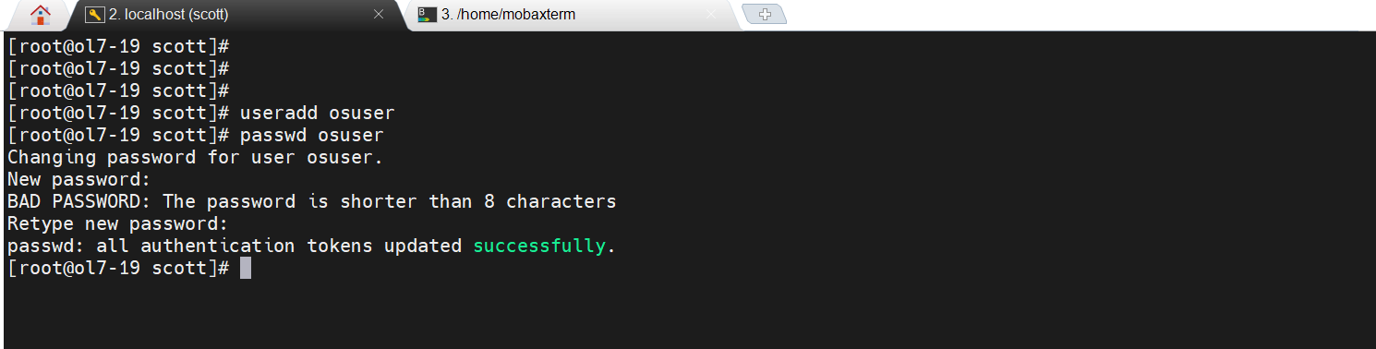

Remove prefixes for the oracle user.

[oracle@ol7-19 ~]$ sqlplus / as sysdba

SQL*Plus: Release 19.0.0.0.0 - Production on Fri Apr 5 17:05:37 2024

Version 19.3.0.0.0

Copyright (c) 1982, 2019, Oracle.  All rights reserved.

Connected to:

Oracle Database 19c Enterprise Edition Release 19.0.0.0.0 - Production

Version 19.3.0.0.0

SQL> create pfile='/tmp/pfile.txt' from spfile;

File created.

SQL> shutdown immediate;

Database closed.

Database dismounted.

ORACLE instance shut down.

SQL> startup

ORACLE instance started.

Total System Global Area 1577055360 bytes

Fixed Size                  9135232 bytes

Variable Size             385875968 bytes

Database Buffers         1174405120 bytes

Redo Buffers                7639040 bytes

Database mounted.

Database opened.

SQL> show parameter os_authent_prefix

NAME                                 TYPE        VALUE

------------------------------------ ----------- ------------------------------

os_authent_prefix                    string      ops$

SQL> create spfile from pfile='/tmp/pfile.txt';

create spfile from pfile='/tmp/pfile.txt'

*

ERROR at line 1:

ORA-32002: cannot create SPFILE already being used by the instance

SQL> shutdown immediate;

Database closed.

Database dismounted.

ORACLE instance shut down.

SQL> create spfile from pfile='/tmp/pfile.txt';

File created.

SQL> startup

ORACLE instance started.

Total System Global Area 1577055360 bytes

Fixed Size                  9135232 bytes

Variable Size             385875968 bytes

Database Buffers         1174405120 bytes

Redo Buffers                7639040 bytes

Database mounted.

Database opened.

SQL> show parameter os_authent_prefix

NAME                                 TYPE        VALUE

------------------------------------ ----------- ------------------------------

os_authent_prefix                    string

SQL>

Create User and Login to Oracle

SQL> ALTER SESSION SET CONTAINER = PDB2;

SQL> CREATE USER osuser IDENTIFIED EXTERNALLY;

SQL> GRANT CREATE SESSION TO osuser;

SQL> exit

$ su osuser

$ sqlplus /

SQL*Plus: Release 19.0.0.0.0 - Production on Sat Apr 6 16:21:28 2024

Version 19.3.0.0.0

Copyright (c) 1982, 2019, Oracle. All rights reserved.

Last Successful login time: Sat Apr 06 2024 15:18:41 +07:00

Connected to:

Oracle Database 19c Enterprise Edition Release 19.0.0.0.0 - Production

Version 19.3.0.0.0

SQL>